UNITED STATES
SECURITIES AND EXCHANGE COMMISSION
WASHINGTON, D.C. 20549

FORM 8-K

CURRENT REPORT
Pursuant to Section 13 or 15(d) of the
Securities Exchange Act of 1934

Date of report (Date of earliest event reported): May 22, 2023

CAPITAL SOUTHWEST CORPORATION
(Exact Name Of Registrant As Specified In Charter)
Texas |  |  | 814-00061 |  |  | 75-1072796
(State or Other Jurisdiction of Incorporation) |  |  | (Commission File Number) |  |  | (IRS Employer Identification No.)

8333 Douglas Avenue, Suite 1100
Dallas, Texas 75225
(Address of Principal Executive Offices) (Zip Code)

Registrant’s telephone number, including area code: (214) 238-5700

Check the appropriate box below if the Form 8-K filing is intended to simultaneously satisfy the filing obligation of the registrant under any of the following provisions (see General Instruction A.2. below):
 |  |  | ☐ |  |  | Written communications pursuant to Rule 425 under the Securities Act (17 CFR 230.425)
 |  |  | ☐ |  |  | Soliciting material pursuant to Rule 14a-12 under the Exchange Act (17 CFR 240.14a-12)
 |  |  | ☐ |  |  | Pre-commencement communications pursuant to Rule 14d-2(b) under the Exchange Act (17 CFR 240.14d-2(b))
 |  |  | ☐ |  |  | Pre-commencement communications pursuant to Rule 13e-4(c) under the Exchange Act (17 CFR 240.13e-4(c))

Securities registered pursuant to Section 12(b) of the Act:
Title of Each Class |  |  | Trading Symbol(s) |  |  | Name of Each Exchange on Which Registered
Common Stock, $0.25 par value per share |  |  | CSWC |  |  | The Nasdaq Global Select Market

Indicate by check mark whether the registrant is an emerging growth company as defined in Rule 405 of the Securities Act of 1933 (§230.405 of this chapter) or Rule 12b-2 of the Securities Exchange Act of 1934 (§240.12b-2 of this chapter).
Emerging growth company |  |  | ☐

If an emerging growth company, indicate by check mark if the registrant has elected not to use the extended transition period for complying with any new or revised financial accounting standards provided pursuant to Section 13(a) of the Exchange Act. ☐

Item 2.02 Results of Operations and Financial Condition.

On May 22, 2023, Capital Southwest Corporation (the “Company”) issued a press release, a copy of which has been furnished as Exhibit 99.1 hereto.

The information furnished in this Current Report on Form 8-K under Item 2.02, including Exhibit 99.1, shall not be deemed “filed” for purposes of Section 18 of the Securities Exchange Act of 1934, as amended (the "Exchange Act"), nor shall it be deemed incorporated by reference into any filing under the Securities Act of 1933, as amended (the "Securities Act"), except as shall be expressly set forth by reference in a future filing.

Item 7.01 Regulation FD Disclosure.

The Company expects to hold a conference call with analysts and investors on May 23, 2023. A copy of the investor presentation slides to be used by the Company on such conference call is furnished as Exhibit 99.2 to this Form 8-K and incorporated herein by reference.

The information set forth under this Item 7.01, including Exhibit 99.2, is being furnished and shall not be deemed “filed” for purposes of Section 18 of the Exchange Act, nor shall it be deemed incorporated by reference into any filing under the Securities Act, except as shall be expressly set forth by specific reference in such filing.

Item 9.01 Financial Statements and Exhibits

(d) Exhibits
Exhibit No. |  |  |  |  |  | Description
99.1 |  |  |  |  |  | Press release issued by Capital Southwest Corporation on May 22, 2023
99.2 |  |  |  |  |  | Investor presentation slides
104 |  |  |  |  |  | Cover Page Interactive Data File (embedded within the Inline XBRL document)

SIGNATURES

Pursuant to the requirements of the Securities Exchange Act of 1934, the registrant has duly caused this report to be signed on its behalf by the undersigned hereunto duly authorized.

Dated: May 22, 2023
 |  |  | By: |  |  | /s/ Bowen S. Diehl
 |  |  |  |  |  | Name: Bowen S. Diehl
 |  |  |  |  |  | Title: Chief Executive Officer and President

Exhibit 99.1

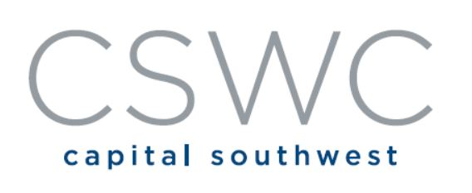 |  |  |  |  |  | 8333 Douglas Avenue, Suite 1100  Dallas, Texas 75225  T 214.238.5700  F 214.238.5701

Capital Southwest Announces Financial Results for Fourth Fiscal Quarter and Fiscal Year Ended March 31, 2023
CSWC Reports Pre-Tax Net Investment Income of $0.65 Per Share for Quarter Ended March 31, 2023
Dallas, Texas – May 22, 2023 – Capital Southwest Corporation (“Capital Southwest,” “CSWC” or the “Company”) (Nasdaq: CSWC), an internally managed business development company focused on providing flexible financing solutions to support the acquisition and growth of middle market businesses, today announced its financial results for the fourth fiscal quarter and fiscal year ended March 31, 2023.
Fourth Quarter Fiscal Year 2023 Financial Highlights
•Total Investment Portfolio: $1.2 billion
◦Credit Portfolio of $1.0 billion:
▪96% 1st Lien Senior Secured Debt
▪$61.7 million in new committed credit investments
▪Weighted Average Yield on Debt Investments: 12.8%
▪Current non-accruals with a fair value of $3.9 million, representing 0.3% of the total investment portfolio
◦Equity Portfolio of $117.5 million, excluding investment in I-45 Senior Loan Fund ("I-45 SLF")
▪$5.6 million in new equity co-investments
◦CSWC Investment in I-45 SLF of $51.3 million at fair value
▪I-45 SLF portfolio of $143.7 million
•Portfolio consists of 36 issuers: 95% 1st Lien Debt
▪$86.0 million of debt outstanding at I-45 SLF
•I-45 SLF fund leverage of 1.34x debt to equity at fair value
▪I-45 SLF paid a $1.9 million quarterly dividend to CSWC; an annualized yield of 14.8%
•Pre-Tax Net Investment Income: $22.8 million, or $0.65 per weighted average share outstanding
•Dividends: Paid $0.53 per share Regular Dividend and $0.05 per share Supplemental Dividend
◦113% LTM Pre-Tax NII Regular Dividend Coverage
◦Total Dividends for the quarter ended March 31, 2023 of $0.58 per share
•Net Realized and Unrealized Depreciation: $4.2 million
◦$2.4 million of net depreciation related to the credit portfolio
◦$1.2 million of net depreciation related to I-45 SLF
◦$0.6 million of net depreciation related to the equity portfolio
•Balance Sheet:
◦Cash and Cash Equivalents: $21.6 million
◦Total Net Assets: $590.4 million
◦Net Asset Value (“NAV”) per Share: $16.37
•Received Baa3 Investment Grade Rating from Moody's Investors Service with Stable Outlook

Fiscal Year 2023 Financial Highlights
•Total Investment Portfolio: Increased by $269.8 million in total fair value, from $936.6 million to $1.2 billion, representing 29% growth during the year
◦Credit Portfolio increased by $243.8 million, representing 31% growth during the year
•Operating Leverage: Improved to 1.9% as of March 31, 2023 from 2.2% as of March 31, 2022
•Pre-Tax Net Investment Income: $69.0 million for the fiscal year, or $2.30 per weighted average diluted share compared to $1.90 per weighted average diluted share in the prior fiscal year, representing 21% growth
•Dividends: Declared and Paid Total Dividends of $2.28 per share
◦$2.03 per share in regular dividends, an increase of 12% compared to the prior year
◦$0.15 per share in special dividends
◦$0.10 per share in supplemental dividends
◦Undistributed Taxable Income ("UTI") balance at the end of the fiscal year ended March 31, 2023 was $0.45 per share

In commenting on the Company’s results, Bowen Diehl, President and Chief Executive Officer, stated, “Our portfolio continued to perform well this quarter, producing $0.65 of pre-tax net investment income. On the capitalization front, we continued to programmatically raise equity through our equity at-the-market program, raising $29.2 million in gross proceeds at 118% of the prevailing NAV per share during the quarter. Over the past twelve months, we have raised over $207 million in equity capital and reduced our regulatory leverage from 1.16x down to 0.88x as of the March 31, 2023 quarter end. In consideration of the performance of our portfolio, improvements in our operating leverage, and rising market interest rates, the Board of Directors has declared an increase in our regular quarterly dividend to $0.54 per share for the June 30, 2023 quarter. In addition, given the excess earnings being generated by our floating rate debt portfolio, our Board of Directors has also declared a supplemental dividend of $0.05 per share for the June 30, 2023 quarter, resulting in total dividends for the June quarter of $0.59 per share. While future dividend declarations are at the discretion of our Board of Directors, it is our intent to continue to distribute quarterly supplemental dividends for the foreseeable future while base rates remain materially above long-term historical averages and we have a meaningful UTI balance. Finally, we are very pleased to have received an investment grade rating from Moody’s Investors Service during the quarter. We believe this is further market corroboration of our strong investment track record, first lien focused investment strategy, and prudent balance sheet management.”

Fourth Quarter Fiscal Year Investment Activities
Originations
During the quarter ended March 31, 2023, the Company originated $67.3 million in new commitments, consisting of investments in five new portfolio companies totaling $49.5 million and add-on commitments in nine portfolio companies totaling $17.8 million. New portfolio company investment transactions that closed during the quarter ended March 31, 2023 are summarized as follows:
C&M Conveyor, Inc. (dba Innoveyance), $13.0 million 1st Lien Senior Secured Debt: Innoveyance is a designer and manufacturer of material handling systems such as conveyor systems, automation systems, transfer cars and more.
Island Pump and Tank, LLC, $9.0 million 1st Lien Senior Secured Debt, $1.5 million Revolving Loan, $0.8 million Preferred Equity: Island Pump and Tank is a leading provider of installation, maintenance, and environmental services to fueling stations in the Northeast.
GPT Industries, LLC, $6.2 million 1st Lien Senior Secured Debt, $3.0 million Revolving Loan, $1.0 million Preferred Equity: GPT Industries is a manufacturer of electrical isolation products for oil and gas pipelines, primarily for maintenance and repair use.
Cavalier Buyer, Inc. (dba James River Cardiology), $6.5 million 1st Lien Senior Secured Debt, $2.0 million Revolving Loan, $0.6 million Preferred and Common Equity: James River Cardiology is a cardiology group practicing out of six clinics, two office-based labs and several local hospitals in the Richmond, VA area.

Guardian Fleet Services, Inc., $4.5 million 1st Lien Senior Secured Debt with Warrants, $1.5 million Preferred Equity: Guardian Fleet Services is a vertically-integrated hauling, towing, recovery, and specialized transportation operator serving the Florida and south Georgia markets.
Prepayments and Exits
During the quarter ended March 31, 2023, the Company received full prepayment on one debt investment totaling $16.8 million.
Amware Fulfillment LLC: Proceeds of $16.8 million, generating an IRR of 13.0%.

Fourth Fiscal Quarter 2023 Operating Results
For the quarter ended March 31, 2023, Capital Southwest reported total investment income of $37.2 million, compared to $32.8 million in the prior quarter. The increase in investment income was primarily attributable to an increase in average debt investments outstanding and an increase in the weighted average yield on investments.
For the quarter ended March 31, 2023, total operating expenses (excluding interest expense) were $5.6 million, compared to $6.2 million in the prior quarter. The decrease in operating expenses was primarily attributable to a decrease in accrued bonus compensation in the current quarter.
For the quarter ended March 31, 2023, interest expense was $8.8 million as compared to $7.9 million in the prior quarter. The increase was primarily attributable to an increase in average debt outstanding and an increase in the weighted average interest rate on total debt.
For the quarter ended March 31, 2023, total pre-tax net investment income was $22.8 million, compared to $18.7 million in the prior quarter.
During the quarter ended March 31, 2023, Capital Southwest recorded total net realized and unrealized losses on investments of $4.2 million, compared to $16.4 million in the prior quarter. For the quarter ended March 31, 2023, this included net realized and unrealized losses on debt investments of $2.4 million, net unrealized losses on I-45 SLF of $1.2 million, net realized and unrealized losses on equity investments of $0.1 million, and $0.5 million of net unrealized depreciation related to deferred tax associated with our wholly owned subsidiary that has elected to be a taxable entity (the "Taxable Subsidiary"). The net increase in net assets resulting from operations was $18.2 million for the quarter, compared to $2.9 million in the prior quarter.
The Company’s NAV at March 31, 2023 was $16.37 per share, as compared to $16.25 at December 31, 2022. The increase in NAV per share from the prior quarter is primarily due to the issuance of common stock at a premium to NAV per share through the Equity ATM Program (as described below) and pre-tax net investment income in excess of dividends paid for the quarter.

Fiscal Year 2023 Operating Results
For the year ended March 31, 2023, Capital Southwest reported total investment income of $119.3 million, compared to $82.2 million in the prior year. The increase in investment income was primarily attributable to an increase in average debt investments outstanding and an increase in the weighted average yield on investments.
For the year ended March 31, 2023, total operating expenses (excluding interest expense) were $21.4 million, compared to $19.0 million in the prior year. The increase in operating expenses during the current year was primarily attributable to an increase in employee compensation, audit fees and in expenses related to the Company's new office space. Additionally, there was an increase in professional fees incurred in connection with the compensation consultant engaged by the Compensation Committee and the initial fee related to being assigned an investment grade rating by Moody's Investors Services.
For the year ended March 31, 2023, interest expense was $28.9 million as compared to $19.9 million in the prior year. The increase was primarily attributable to an increase in average debt outstanding and an increase in the weighted average interest rate on total debt.
For the year ended March 31, 2023, total pre-tax net investment income was $69.0 million, compared to $43.3 million in the prior year.

During the year ended March 31, 2023, Capital Southwest recorded total net realized and unrealized losses on investments of $35.6 million, compared to net realized and unrealized gains on investments of $17.3 million in the prior year. For the year ended March 31, 2023, this included net realized and unrealized losses on debt investments of $24.9 million, net unrealized losses on I-45 SLF of $11.1 million, net realized and unrealized gains on equity investments of $6.9 million, and $6.5 million of net unrealized depreciation related to deferred tax associated with the Taxable Subsidiary. The net increase in net assets resulting from operations was $33.1 million for the year, compared to $42.8 million in the prior year.
The Company’s NAV at March 31, 2023 was $16.37 per share, as compared to $16.86 at March 31, 2022. The decrease in NAV per share from the prior year is primarily due to net realized and unrealized losses on investments, partially offset by the issuance of common stock at a premium to NAV per share through both an underwritten public equity offering and the Equity ATM Program (as described below).
Liquidity and Capital Resources
At March 31, 2023, Capital Southwest had approximately $21.6 million in unrestricted cash and money market balances, $235.0 million of total debt outstanding on the Credit Facility (as defined below), $139.1 million, net of unamortized debt issuance costs, of the 4.50% Notes due January 2026 outstanding, $147.3 million, net of unamortized debt issuance costs, of the 3.375% Notes due October 2026 and $116.3 million, net of unamortized debt issuance costs, of SBA Debentures (as defined below) outstanding. As of March 31, 2023, Capital Southwest had $164.4 million in available borrowings under the Credit Facility. The regulatory debt to equity ratio at the end of the quarter was 0.88 to 1.
On November 17, 2022, the Company completed an underwritten public equity offering of 2,534,436 shares of common stock, including shares issuable pursuant to the underwriters' option to purchase additional shares, at a public offering price of $18.15 per share, raising $46.0 million of gross proceeds. Net proceeds were $44.1 million after deducting underwriting discounts and offering expenses.
The Company has an "at-the-market" offering (the "Equity ATM Program"), pursuant to which the Company may offer and sell, from time to time through sales agents, shares of its common stock having an aggregate offering price of up to $650,000,000. During the quarter ended March 31, 2023, the Company sold 1,526,016 shares of its common stock under the Equity ATM Program at a weighted-average price of $19.15 per share, raising $29.2 million of gross proceeds. Net proceeds were $28.8 million after commissions to the sales agents on shares sold. Cumulative to date, the Company has sold 16,613,122 shares of its common stock under the Equity ATM Program at a weighted-average price of $20.75, raising $344.7 million of gross proceeds. Net proceeds were $339.1 million after commissions to the sales agents on shares sold. As of March 31, 2023, the Company has $305.3 million available under the Equity ATM Program.
In August 2016, CSWC entered into a senior secured credit facility (the “Credit Facility”) to provide additional liquidity to support its investment and operational activities. Borrowings under the Credit Facility accrue interest on a per annum basis at a rate equal to the applicable SOFR rate plus 2.15%. The Credit Facility's revolver period ends on August 9, 2025 with a final maturity of August 9, 2026. At March 31, 2023, the Credit Facility had total commitments of $400 million from a group or eleven bank lenders and $235.0 million in borrowings outstanding.
On April 20, 2021, our wholly owned subsidiary, Capital Southwest SBIC I, LP (“SBIC I”), received a license from the Small Business Administration (the "SBA") to operate as a Small Business Investment Company ("SBIC") under Section 301(c) of the Small Business Investment Act of 1958, as amended. The SBIC license allows SBIC I to obtain leverage by issuing SBA-guaranteed debentures ("SBA Debentures"), subject to the issuance of a leverage commitment by the SBA. SBA debentures are loans issued to an SBIC that have interest payable semi-annually and a ten-year maturity. The interest rate is fixed shortly after issuance at a market-driven spread over U.S. Treasury Notes with ten-year maturities. Current statutes and regulations permit SBIC I to borrow up to $175 million in SBA Debentures with at least $87.5 million in regulatory capital, subject to SBA approval. As of March 31, 2023, SBIC I had a total leverage commitment from the SBA in the amount of $130.0 million, of which $10.0 million remains unused.
In November 2015, I-45 SLF entered into a senior secured credit facility led by Deutsche Bank. On March 30, 2023, the I-45 credit facility was amended to permanently reduce total commitments to $100 million from a group of four bank lenders. After giving effect to the amendment, borrowings under the I-45 credit facility bear interest at a rate equal to Term SOFR plus 2.41%. The I-45 credit facility is scheduled to mature in March 2026. As of March 31, 2023, I-45 SLF had $86.0 million in borrowings outstanding under the I-45 credit facility.

Share Repurchase Program
On July 28, 2021, the Company's board of directors (the "Board") approved a share repurchase program authorizing the Company to repurchase up to $20 million of its outstanding shares of common stock in the open market at certain thresholds below its NAV per share, in accordance with guidelines specified in Rules 10b5-1(c)(1)(i)(B) and 10b-18 under the Securities Exchange Act of 1934. On August 31, 2021, the Company entered into a share repurchase agreement, which became effective immediately, and the Company will cease purchasing its common stock under the share repurchase program upon the earlier of, among other things: (1) the date on which the aggregate purchase price for all shares equals $20 million including, without limitation, all applicable fees, costs and expenses; or (2) upon written notice by the Company to the broker that the share repurchase agreement is terminated. During the quarter ended March 31, 2023, the Company did not repurchase any shares of the Company’s common stock under the share repurchase program.

Regular Dividend of $0.54 Per Share and Supplemental Dividend of $0.05 Per Share for Quarter Ended June 30, 2023

On April 26, 2023, the Board declared a total dividend of $0.59 per share for the quarter ended June 30, 2023, comprised of a Regular Dividend of $0.54 per share and a Supplemental Dividend of $0.05 per share.
The Company's dividend will be payable as follows:

Regular Dividend

Amount Per Share: $0.54
Ex-Dividend Date: June 14, 2023
Record Date: June 15, 2023
Payment Date: June 30, 2023

Supplemental Dividend

Amount Per Share: $0.05
Ex-Dividend Date: June 14, 2023
Record Date: June 15, 2023
Payment Date: June 30, 2023

When declaring dividends, the Board reviews estimates of taxable income available for distribution, which may differ from net investment income under generally accepted accounting principles. The final determination of taxable income for each year, as well as the tax attributes for dividends in such year, will be made after the close of the tax year.

Capital Southwest maintains a dividend reinvestment plan ("DRIP") that provides for the reinvestment of dividends on behalf of its registered stockholders who hold their shares with Capital Southwest’s transfer agent and registrar, American Stock Transfer and Trust Company. Under the DRIP, if the Company declares a dividend, registered stockholders who have opted into the DRIP by the dividend record date will have their dividend automatically reinvested into additional shares of Capital Southwest common stock.

Fourth Quarter 2023 Earnings Results Conference Call and Webcast
Capital Southwest has scheduled a conference call on Tuesday, May 23, 2023, at 11:00 a.m. Eastern Time to discuss the fourth quarter 2023 financial results. You may access the call by using the Investor Relations section of Capital Southwest's website at www.capitalsouthwest.com, or by using http://edge.media-server.com/mmc/p/654v82e7.
An audio archive of the conference call will also be available on the Investor Relations section of Capital Southwest’s website.
For a more detailed discussion of the financial and other information included in this press release, please refer to the Capital Southwest's Annual Report on Form 10-K for the year ended March 31, 2023 to be filed with the Securities and Exchange Commission and Capital Southwest’s Fourth Fiscal Quarter 2023 Earnings Presentation to be posted on the Investor Relations section of Capital Southwest’s website at www.capitalsouthwest.com.

About Capital Southwest
Capital Southwest Corporation (Nasdaq: CSWC) is a Dallas, Texas-based, internally managed business development company with approximately $1.2 billion in investments at fair value as of March 31, 2023. Capital Southwest is a middle market lending firm focused on supporting the acquisition and growth of middle market businesses with $5 million to $35 million investments across the capital structure, including first lien, second lien and non-control equity co-investments. As a public company with a permanent capital base, Capital Southwest has the flexibility to be creative in its financing solutions and to invest to support the growth of its portfolio companies over long periods of time.

Forward-Looking Statements
This press release contains historical information and forward-looking statements with respect to the business and investments of Capital Southwest, including, but not limited to, the statements about Capital Southwest's future performance and financial performance and financial condition, and the timing, form and amount of any distributions or supplemental dividends in the future. Forward-looking statements are statements that are not historical statements and can often be identified by words such as "will," "believe," "expect" and similar expressions and variations or negatives of these words. These statements are based on management's current expectations, assumptions and beliefs. They are not guarantees of future results and are subject to numerous risks, uncertainties and assumptions that could cause actual results to differ materially from those expressed in any forward-looking statement. These risks include risks related to: changes in the markets in which Capital Southwest invests; changes in the financial, capital, and lending markets; changes in the interest rate environment and its impact on our business and our portfolio companies; regulatory changes; tax treatment; our ability to operate our wholly owned subsidiary, Capital Southwest SBIC I, LP, as a small business investment company; an economic downturn and its impact on the ability of our portfolio companies to operate and the investment opportunities available to us; the impact of supply chain constraints and labor shortages on our portfolio companies; and the elevated levels of inflation and its impact on our portfolio companies and the industries in which we invests.

Readers should not place undue reliance on any forward-looking statements and are encouraged to review Capital Southwest's Annual Report on Form 10-K for the year ended March 31, 2023 and subsequent filings, including the "Risk Factors" sections therein, with the Securities and Exchange Commission for a more complete discussion of the risks and other factors that could affect any forward-looking statements. Except as required by the federal securities laws, Capital Southwest does not undertake any obligation to publicly update or revise any forward-looking statements, whether as a result of new information, future events, changing circumstances or any other reason after the date of this press release.

Investor Relations Contact:
Michael S. Sarner, Chief Financial Officer
214-884-3829

CAPITAL SOUTHWEST CORPORATION AND SUBSIDIARIES
CONSOLIDATED STATEMENTS OF ASSETS AND LIABILITIES
(In thousands, except shares and per share data)
 |  |  | March 31, |  |  |  |  |  | March 31,
 |  |  | 2023 |  |  |  |  |  | 2022
 |  |  | (Unaudited)
Assets
Investments at fair value:
Non-control/Non-affiliate investments (Cost: $947,829 and $721,392, respectively) |  |  | $ | 966,627 |  |  |  |  | $ | 747,132
Affiliate investments (Cost: $191,523 and $140,911, respectively) |  |  | 188,505 |  |  |  |  |  | 131,879
Control investments (Cost: $80,800 and $76,000, respectively) |  |  | 51,256 |  |  |  |  |  | 57,603
Total investments (Cost: $1,220,152 and $938,303, respectively) |  |  | 1,206,388 |  |  |  |  |  | 936,614
Cash and cash equivalents |  |  | 21,585 |  |  |  |  |  | 11,431
Receivables:
Dividends and interest |  |  | 18,430 |  |  |  |  |  | 12,106
Escrow |  |  | 363 |  |  |  |  |  | 1,344
Other |  |  | 647 |  |  |  |  |  | 2,238
Income tax receivable |  |  | 368 |  |  |  |  |  | 158
Debt issuance costs (net of accumulated amortization of $5,642 and $4,573, respectively) |  |  | 3,717 |  |  |  |  |  | 4,038
Other assets |  |  | 6,186 |  |  |  |  |  | 6,028
Total assets |  |  | $ | 1,257,684 |  |  |  |  | $ | 973,957
Liabilities
SBA Debentures (Par value: $120,000 and $40,000, respectively) |  |  | $ | 116,330 |  |  |  |  | $ | 38,352
January 2026 Notes (Par value: $140,000 and $140,000, respectively) |  |  | 139,051 |  |  |  |  |  | 138,714
October 2026 Notes (Par value: $150,000 and $150,000, respectively) |  |  | 147,263 |  |  |  |  |  | 146,522
Credit facility |  |  | 235,000 |  |  |  |  |  | 205,000
Other liabilities |  |  | 16,761 |  |  |  |  |  | 14,808
Accrued restoration plan liability |  |  | 598 |  |  |  |  |  | 2,707
Income tax payable |  |  | 156 |  |  |  |  |  | 1,240
Deferred tax liability |  |  | 12,117 |  |  |  |  |  | 5,747
Total liabilities |  |  | 667,276 |  |  |  |  |  | 553,090
Commitments and contingencies (Note 10)
Net Assets
Common stock, $0.25 par value: authorized, 40,000,000 shares; issued, 38,415,937 shares at March 31, 2023 and 27,298,032 shares at March 31, 2022 |  |  | 9,604 |  |  |  |  |  | 6,825
Additional paid-in capital |  |  | 646,586 |  |  |  |  |  | 448,235
Total distributable (loss) earnings |  |  | (41,845) |  |  |  |  |  | (10,256)
Treasury stock - at cost, 2,339,512 shares |  |  | (23,937) |  |  |  |  |  | (23,937)
Total net assets |  |  | 590,408 |  |  |  |  |  | 420,867
Total liabilities and net assets |  |  | $ | 1,257,684 |  |  |  |  | $ | 973,957
Net asset value per share (36,076,425 shares outstanding at March 31, 2023 and 24,958,520 shares outstanding at March 31, 2022) |  |  | $ | 16.37 |  |  |  |  | $ | 16.86

CAPITAL SOUTHWEST CORPORATION AND SUBSIDIARIES
CONSOLIDATED STATEMENTS OF OPERATIONS
(Unaudited)
(In thousands, except shares and per share data)
 |  |  |  |  | Years Ended
 |  |  |  |  | March 31,
 |  |  |  |  |  |  | 2023 |  |  |  |  |  | 2022 |  |  |  |  |  | 2021
Investment income:
Interest income:
Non-control/Non-affiliate investments |  |  |  |  |  |  | $ | 87,982 |  |  |  |  | $ | 58,136 |  |  |  |  | $ | 42,880
Affiliate investments |  |  |  |  |  |  | 11,658 |  |  |  |  |  | 7,122 |  |  |  |  |  | 6,126
Payment-in-kind interest income:
Non-control/Non-affiliate investments |  |  |  |  |  |  | 2,382 |  |  |  |  |  | 2,051 |  |  |  |  |  | 4,268
Affiliate investments |  |  |  |  |  |  | 3,060 |  |  |  |  |  | 1,160 |  |  |  |  |  | 3,018
Dividend income:
Non-control/Non-affiliate investments |  |  |  |  |  |  | 1,824 |  |  |  |  |  | 1,654 |  |  |  |  |  | 1,752
Affiliate investments |  |  |  |  |  |  | 141 |  |  |  |  |  | 28 |  |  |  |  |  | 33
Control investments |  |  |  |  |  |  | 7,337 |  |  |  |  |  | 6,720 |  |  |  |  |  | 6,609
Fee income:
Non-control/Non-affiliate investments |  |  |  |  |  |  | 4,057 |  |  |  |  |  | 4,833 |  |  |  |  |  | 3,233
Affiliate investments |  |  |  |  |  |  | 638 |  |  |  |  |  | 494 |  |  |  |  |  | 122
Control investments |  |  |  |  |  |  | 100 |  |  |  |  |  | — |  |  |  |  |  | —
Other income |  |  |  |  |  |  | 121 |  |  |  |  |  | 17 |  |  |  |  |  | 21
Total investment income |  |  |  |  |  |  | 119,300 |  |  |  |  |  | 82,215 |  |  |  |  |  | 68,062
Operating expenses:
Compensation |  |  |  |  |  |  | 9,870 |  |  |  |  |  | 8,838 |  |  |  |  |  | 7,756
Share-based compensation |  |  |  |  |  |  | 3,705 |  |  |  |  |  | 3,585 |  |  |  |  |  | 2,944
Interest |  |  |  |  |  |  | 28,873 |  |  |  |  |  | 19,924 |  |  |  |  |  | 17,941
Professional fees |  |  |  |  |  |  | 3,180 |  |  |  |  |  | 2,489 |  |  |  |  |  | 2,193
General and administrative |  |  |  |  |  |  | 4,632 |  |  |  |  |  | 4,077 |  |  |  |  |  | 3,115
Total operating expenses |  |  |  |  |  |  | 50,260 |  |  |  |  |  | 38,913 |  |  |  |  |  | 33,949
Income before taxes |  |  |  |  |  |  | 69,040 |  |  |  |  |  | 43,302 |  |  |  |  |  | 34,113
Federal income, excise and other taxes |  |  |  |  |  |  | 630 |  |  |  |  |  | 181 |  |  |  |  |  | 637
Deferred taxes |  |  |  |  |  |  | (301) |  |  |  |  |  | 434 |  |  |  |  |  | 1,805
Total income tax provision |  |  |  |  |  |  | 329 |  |  |  |  |  | 615 |  |  |  |  |  | 2,442
Net investment income |  |  |  |  |  |  | $ | 68,711 |  |  |  |  | $ | 42,687 |  |  |  |  | $ | 31,671
Realized (loss) gain
Non-control/Non-affiliate investments |  |  |  |  |  |  | $ | (5,872) |  |  |  |  | $ | 7,136 |  |  |  |  | $ | (6,908)
Affiliate investments |  |  |  |  |  |  | (11,027) |  |  |  |  |  | 140 |  |  |  |  |  | (1,628)
Income tax provision |  |  |  |  |  |  | (130) |  |  |  |  |  | (1,442) |  |  |  |  |  | —
Total net realized (loss) gain on investments, net of tax |  |  |  |  |  |  | (17,029) |  |  |  |  |  | 5,834 |  |  |  |  |  | (8,536)
Net unrealized (depreciation) appreciation on investments
Non-control/Non-affiliate investments |  |  |  |  |  |  | (6,942) |  |  |  |  |  | 20,940 |  |  |  |  |  | 21,218
Affiliate investments |  |  |  |  |  |  | 6,014 |  |  |  |  |  | (4,750) |  |  |  |  |  | (2,825)
Control investments |  |  |  |  |  |  | (11,147) |  |  |  |  |  | (2,755) |  |  |  |  |  | 12,598
Income tax provision |  |  |  |  |  |  | (6,514) |  |  |  |  |  | (1,968) |  |  |  |  |  | (2,236)
Total net unrealized (depreciation) appreciation on investments, net of tax |  |  |  |  |  |  | (18,589) |  |  |  |  |  | 11,467 |  |  |  |  |  | 28,755
Net realized and unrealized (losses) gains on investments |  |  |  |  |  |  | (35,618) |  |  |  |  |  | 17,301 |  |  |  |  |  | 20,219
Realized loss on extinguishment of debt |  |  |  |  |  |  | — |  |  |  |  |  | (17,087) |  |  |  |  |  | (1,007)
Realized loss on disposal of fixed assets |  |  |  |  |  |  | — |  |  |  |  |  | (86) |  |  |  |  |  | —
Net increase in net assets from operations |  |  |  |  |  |  | $ | 33,093 |  |  |  |  | $ | 42,815 |  |  |  |  | $ | 50,883
Pre-tax net investment income per share - basic and diluted |  |  |  |  |  |  | $ | 2.30 |  |  |  |  | $ | 1.90 |  |  |  |  | $ | 1.79
Net investment income per share – basic and diluted |  |  |  |  |  |  | $ | 2.29 |  |  |  |  | $ | 1.87 |  |  |  |  | $ | 1.66
Net increase in net assets from operations – basic and diluted |  |  |  |  |  |  | $ | 1.10 |  |  |  |  | $ | 1.87 |  |  |  |  | $ | 2.67
Weighted average shares outstanding – basic and diluted |  |  |  |  |  |  | 30,015,533 |  |  |  |  |  | 22,839,835 |  |  |  |  |  | 19,060,131
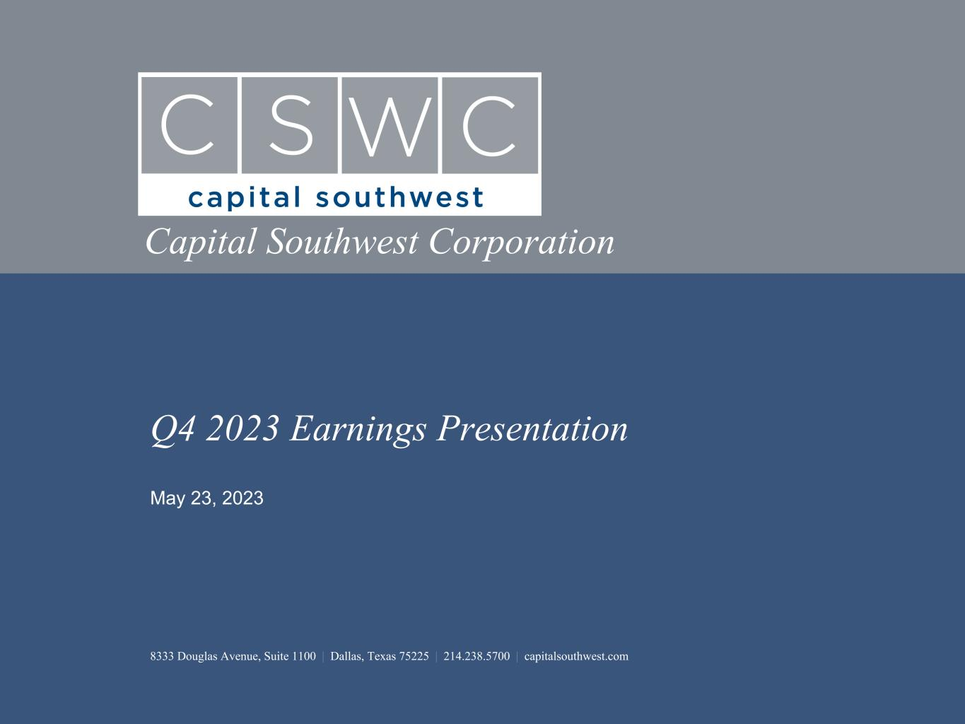

Q4 2023 Earnings Presentation 8333 Douglas Avenue, Suite 1100 | Dallas, Texas 75225 | 214.238.5700 | capitalsouthwest.com May 23, 2023 Capital Southwest Corporation

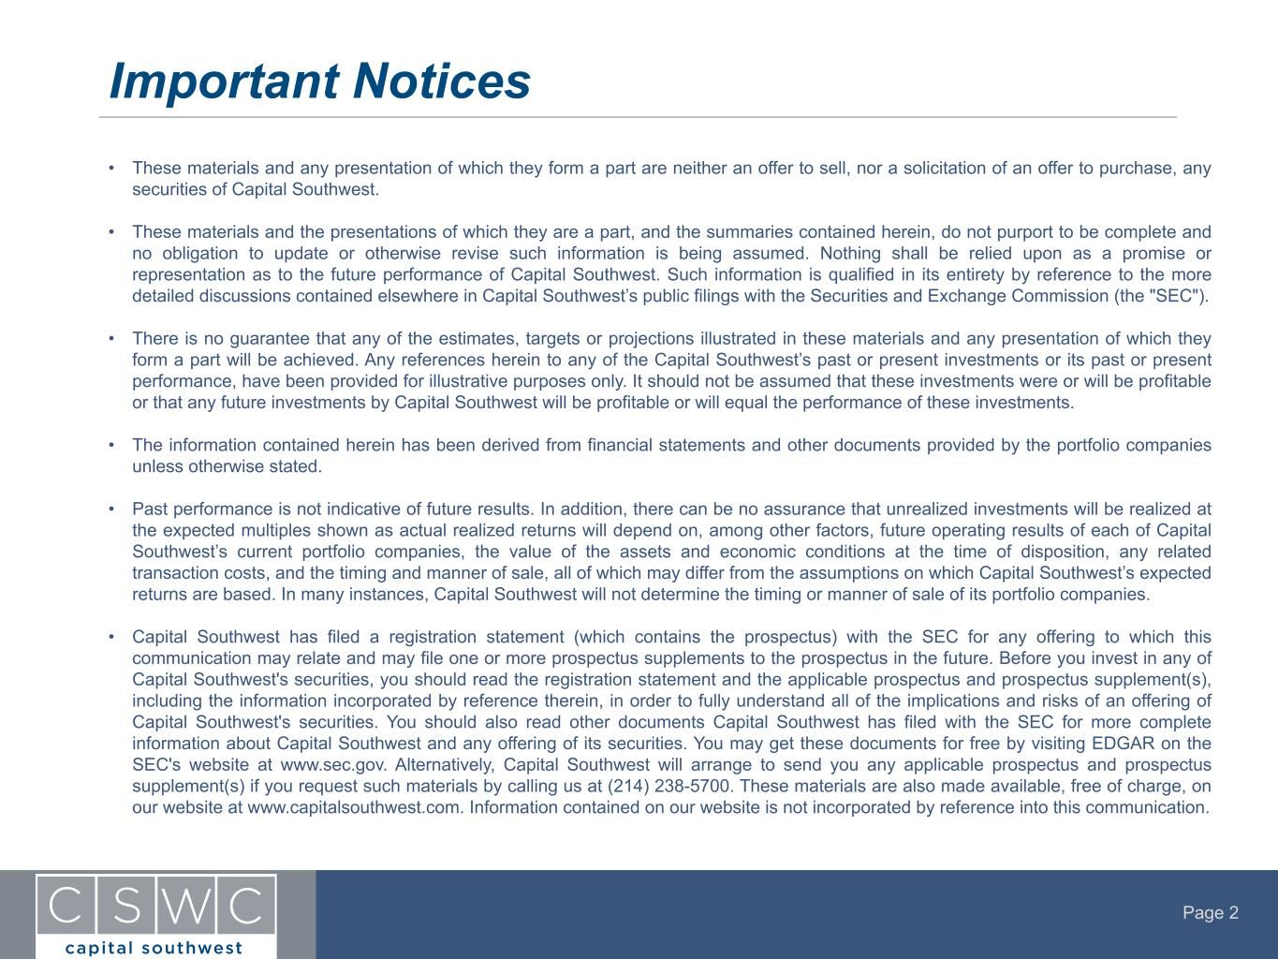
Page 2 Important Notices • These materials and any presentation of which they form a part are neither an offer to sell, nor a solicitation of an offer to purchase, any securities of Capital Southwest. • These materials and the presentations of which they are a part, and the summaries contained herein, do not purport to be complete and no obligation to update or otherwise revise such information is being assumed. Nothing shall be relied upon as a promise or representation as to the future performance of Capital Southwest. Such information is qualified in its entirety by reference to the more detailed discussions contained elsewhere in Capital Southwest’s public filings with the Securities and Exchange Commission (the "SEC"). • There is no guarantee that any of the estimates, targets or projections illustrated in these materials and any presentation of which they form a part will be achieved. Any references herein to any of the Capital Southwest’s past or present investments or its past or present performance, have been provided for illustrative purposes only. It should not be assumed that these investments were or will be profitable or that any future investments by Capital Southwest will be profitable or will equal the performance of these investments. • The information contained herein has been derived from financial statements and other documents provided by the portfolio companies unless otherwise stated. • Past performance is not indicative of future results. In addition, there can be no assurance that unrealized investments will be realized at the expected multiples shown as actual realized returns will depend on, among other factors, future operating results of each of Capital Southwest’s current portfolio companies, the value of the assets and economic conditions at the time of disposition, any related transaction costs, and the timing and manner of sale, all of which may differ from the assumptions on which Capital Southwest’s expected returns are based. In many instances, Capital Southwest will not determine the timing or manner of sale of its portfolio companies. • Capital Southwest has filed a registration statement (which contains the prospectus) with the SEC for any offering to which this communication may relate and may file one or more prospectus supplements to the prospectus in the future. Before you invest in any of Capital Southwest's securities, you should read the registration statement and the applicable prospectus and prospectus supplement(s), including the information incorporated by reference therein, in order to fully understand all of the implications and risks of an offering of Capital Southwest's securities. You should also read other documents Capital Southwest has filed with the SEC for more complete information about Capital Southwest and any offering of its securities. You may get these documents for free by visiting EDGAR on the SEC's website at www.sec.gov. Alternatively, Capital Southwest will arrange to send you any applicable prospectus and prospectus supplement(s) if you request such materials by calling us at (214) 238-5700. These materials are also made available, free of charge, on our website at www.capitalsouthwest.com. Information contained on our website is not incorporated by reference into this communication.

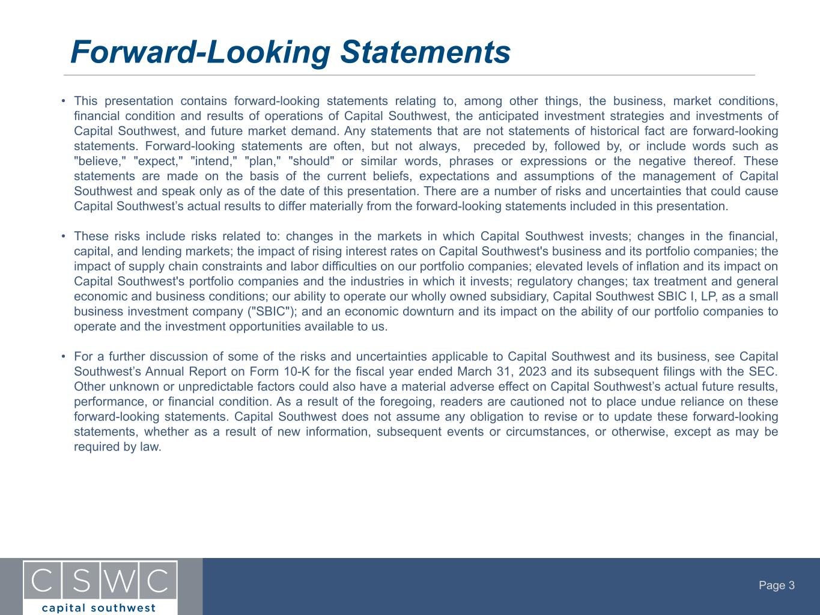
Page 3 • This presentation contains forward-looking statements relating to, among other things, the business, market conditions, financial condition and results of operations of Capital Southwest, the anticipated investment strategies and investments of Capital Southwest, and future market demand. Any statements that are not statements of historical fact are forward-looking statements. Forward-looking statements are often, but not always, preceded by, followed by, or include words such as "believe," "expect," "intend," "plan," "should" or similar words, phrases or expressions or the negative thereof. These statements are made on the basis of the current beliefs, expectations and assumptions of the management of Capital Southwest and speak only as of the date of this presentation. There are a number of risks and uncertainties that could cause Capital Southwest’s actual results to differ materially from the forward-looking statements included in this presentation. • These risks include risks related to: changes in the markets in which Capital Southwest invests; changes in the financial, capital, and lending markets; the impact of rising interest rates on Capital Southwest's business and its portfolio companies; the impact of supply chain constraints and labor difficulties on our portfolio companies; elevated levels of inflation and its impact on Capital Southwest's portfolio companies and the industries in which it invests; regulatory changes; tax treatment and general economic and business conditions; our ability to operate our wholly owned subsidiary, Capital Southwest SBIC I, LP, as a small business investment company ("SBIC"); and an economic downturn and its impact on the ability of our portfolio companies to operate and the investment opportunities available to us. • For a further discussion of some of the risks and uncertainties applicable to Capital Southwest and its business, see Capital Southwest’s Annual Report on Form 10-K for the fiscal year ended March 31, 2023 and its subsequent filings with the SEC. Other unknown or unpredictable factors could also have a material adverse effect on Capital Southwest’s actual future results, performance, or financial condition. As a result of the foregoing, readers are cautioned not to place undue reliance on these forward-looking statements. Capital Southwest does not assume any obligation to revise or to update these forward-looking statements, whether as a result of new information, subsequent events or circumstances, or otherwise, except as may be required by law. Forward-Looking Statements

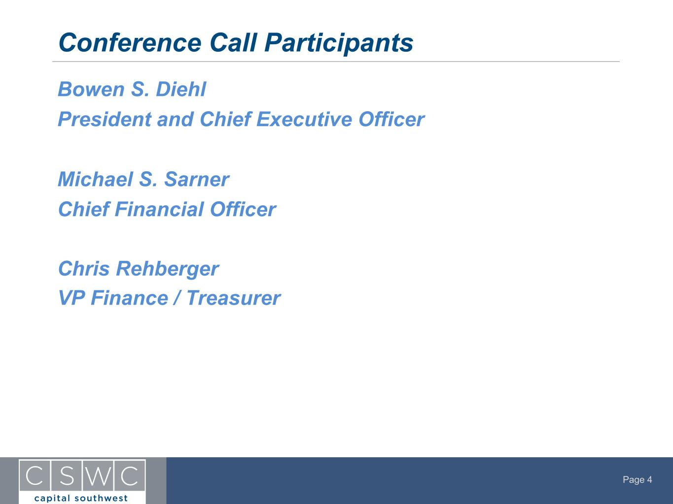
Page 4 Bowen S. Diehl President and Chief Executive Officer Michael S. Sarner Chief Financial Officer Chris Rehberger VP Finance / Treasurer Conference Call Participants

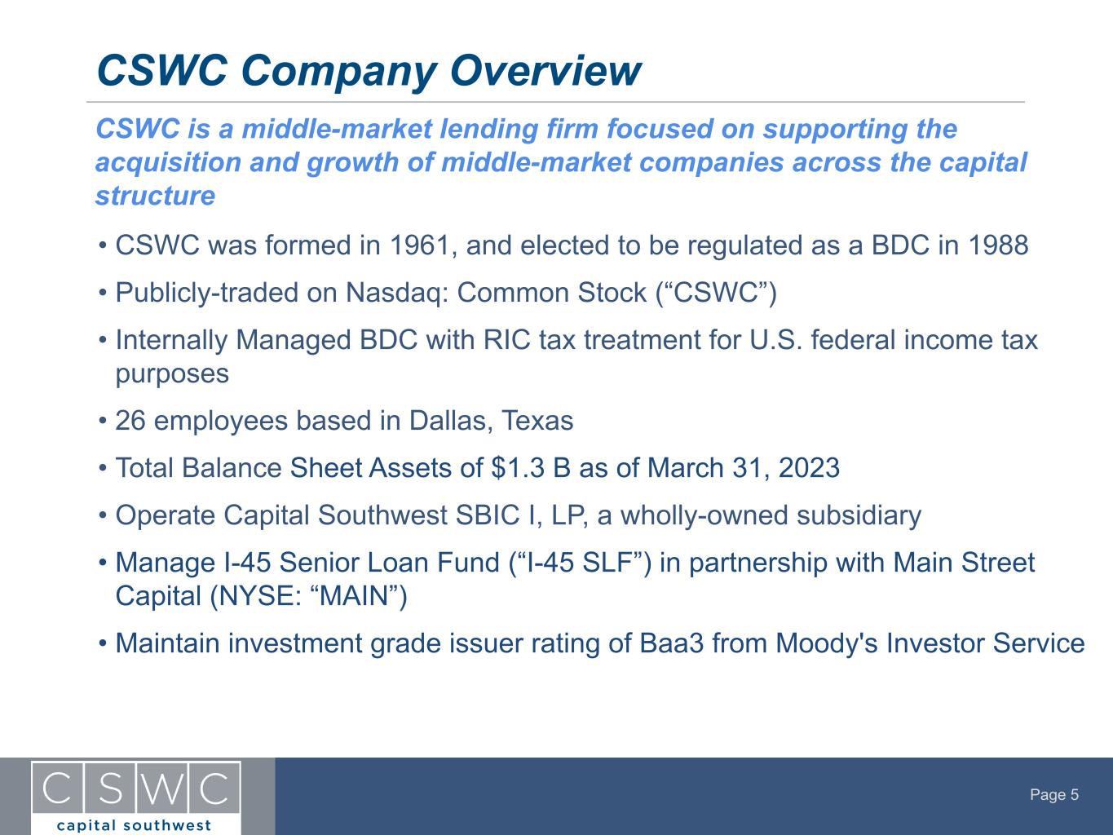
Page 5 • CSWC was formed in 1961, and elected to be regulated as a BDC in 1988 • Publicly-traded on Nasdaq: Common Stock (“CSWC”) • Internally Managed BDC with RIC tax treatment for U.S. federal income tax purposes • 26 employees based in Dallas, Texas • Total Balance Sheet Assets of $1.3 B as of March 31, 2023 • Operate Capital Southwest SBIC I, LP, a wholly-owned subsidiary • Manage I-45 Senior Loan Fund (“I-45 SLF”) in partnership with Main Street Capital (NYSE: “MAIN”) • Maintain investment grade issuer rating of Baa3 from Moody's Investor Service CSWC Company Overview CSWC is a middle-market lending firm focused on supporting the acquisition and growth of middle-market companies across the capital structure

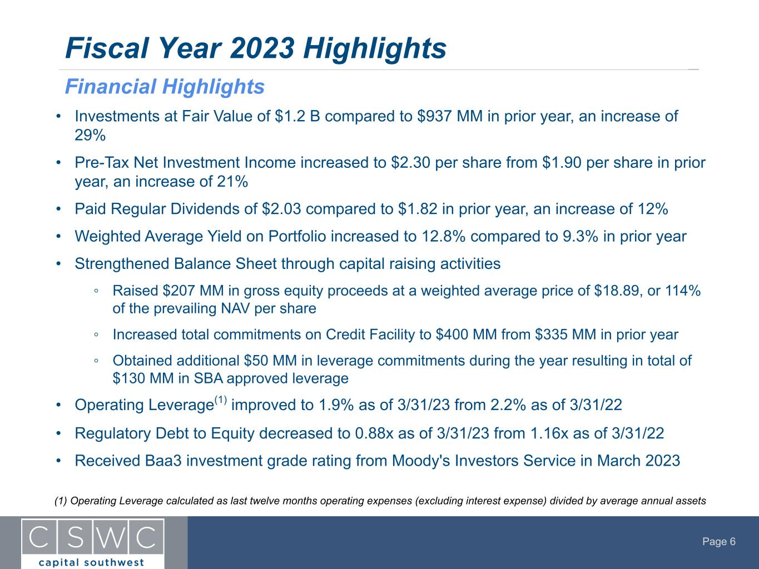
Page 6 Fiscal Year 2023 Highlights Financial Highlights (1) Operating Leverage calculated as last twelve months operating expenses (excluding interest expense) divided by average annual assets • Investments at Fair Value of $1.2 B compared to $937 MM in prior year, an increase of 29% • Pre-Tax Net Investment Income increased to $2.30 per share from $1.90 per share in prior year, an increase of 21% • Paid Regular Dividends of $2.03 compared to $1.82 in prior year, an increase of 12% • Weighted Average Yield on Portfolio increased to 12.8% compared to 9.3% in prior year • Strengthened Balance Sheet through capital raising activities ◦ Raised $207 MM in gross equity proceeds at a weighted average price of $18.89, or 114% of the prevailing NAV per share ◦ Increased total commitments on Credit Facility to $400 MM from $335 MM in prior year ◦ Obtained additional $50 MM in leverage commitments during the year resulting in total of $130 MM in SBA approved leverage • Operating Leverage(1) improved to 1.9% as of 3/31/23 from 2.2% as of 3/31/22 • Regulatory Debt to Equity decreased to 0.88x as of 3/31/23 from 1.16x as of 3/31/22 • Received Baa3 investment grade rating from Moody's Investors Service in March 2023

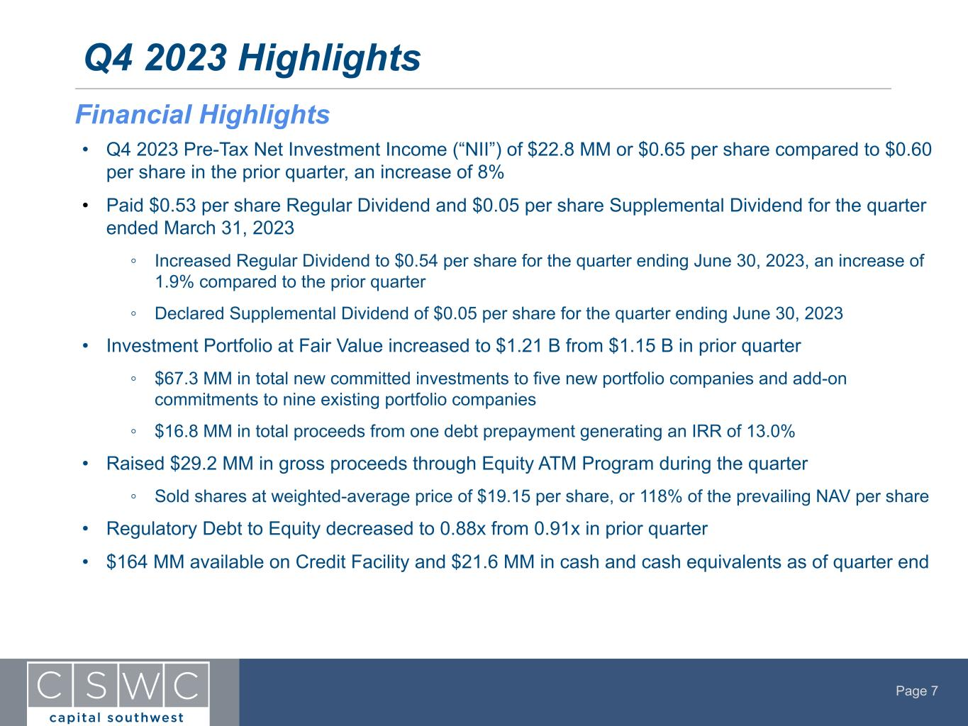
Page 7 • Q4 2023 Pre-Tax Net Investment Income (“NII”) of $22.8 MM or $0.65 per share compared to $0.60 per share in the prior quarter, an increase of 8% • Paid $0.53 per share Regular Dividend and $0.05 per share Supplemental Dividend for the quarter ended March 31, 2023 ◦ Increased Regular Dividend to $0.54 per share for the quarter ending June 30, 2023, an increase of 1.9% compared to the prior quarter ◦ Declared Supplemental Dividend of $0.05 per share for the quarter ending June 30, 2023 • Investment Portfolio at Fair Value increased to $1.21 B from $1.15 B in prior quarter ◦ $67.3 MM in total new committed investments to five new portfolio companies and add-on commitments to nine existing portfolio companies ◦ $16.8 MM in total proceeds from one debt prepayment generating an IRR of 13.0% • Raised $29.2 MM in gross proceeds through Equity ATM Program during the quarter ◦ Sold shares at weighted-average price of $19.15 per share, or 118% of the prevailing NAV per share • Regulatory Debt to Equity decreased to 0.88x from 0.91x in prior quarter • $164 MM available on Credit Facility and $21.6 MM in cash and cash equivalents as of quarter end Q4 2023 Highlights Financial Highlights

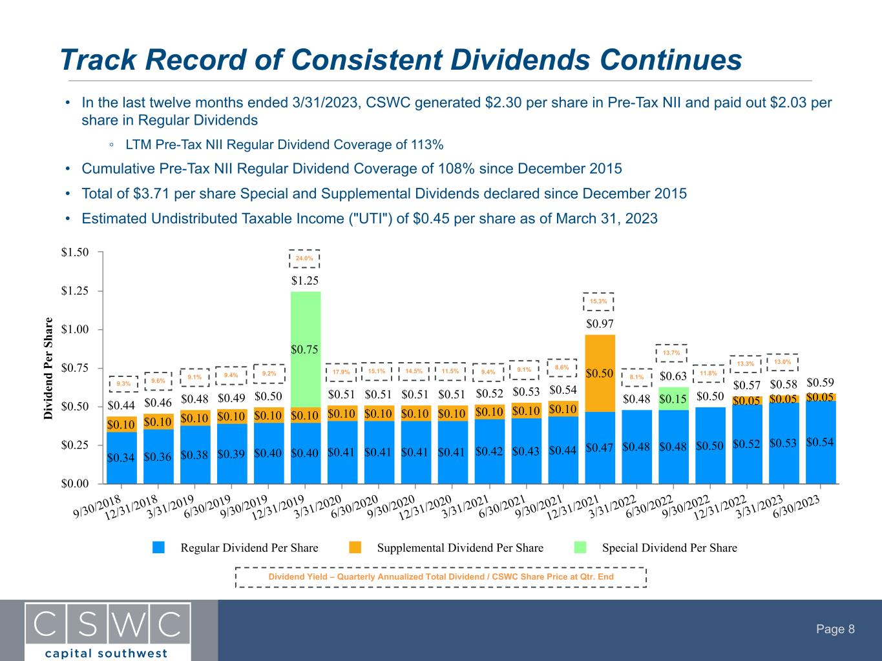
Page 8 • In the last twelve months ended 3/31/2023, CSWC generated $2.30 per share in Pre-Tax NII and paid out $2.03 per share in Regular Dividends ◦ LTM Pre-Tax NII Regular Dividend Coverage of 113% • Cumulative Pre-Tax NII Regular Dividend Coverage of 108% since December 2015 • Total of $3.71 per share Special and Supplemental Dividends declared since December 2015 • Estimated Undistributed Taxable Income ("UTI") of $0.45 per share as of March 31, 2023 Track Record of Consistent Dividends Continues Dividend Yield – Quarterly Annualized Total Dividend / CSWC Share Price at Qtr. End D iv id en d Pe r Sh ar e $0.48 $0.50 $0.44 $0.46 $0.48 $0.49 $0.50 $0.51 $0.51 $0.51 $0.51 $0.52 $0.53 $0.54 $0.97 $0.57 $0.58 $0.59 $1.25 $0.63 $0.34 $0.36 $0.38 $0.39 $0.40 $0.40 $0.41 $0.41 $0.41 $0.41 $0.42 $0.43 $0.44 $0.47 $0.48 $0.48 $0.50 $0.52 $0.53 $0.54 $0.10 $0.10 $0.10 $0.10 $0.10 $0.10 $0.10 $0.10 $0.10 $0.10 $0.10 $0.10 $0.10 $0.50 $0.05 $0.05 $0.05 $0.75 $0.15 Regular Dividend Per Share Supplemental Dividend Per Share Special Dividend Per Share 9/30/2018 12/31/2018 3/31/2019 6/30/2019 9/30/2019 12/31/2019 3/31/2020 6/30/2020 9/30/2020 12/31/2020 3/31/2021 6/30/2021 9/30/2021 12/31/2021 3/31/2022 6/30/2022 9/30/2022 12/31/2022 3/31/2023 6/30/2023 $0.00 $0.25 $0.50 $0.75 $1.00 $1.25 $1.50 9.3% 9.6% 9.1% 9.4% 9.2% 24.0% 17.9% 15.1% 14.5% 11.5% 9.4% 9.1% 8.6% 15.3% 8.1% 13.7% 13.3% 13.0% 11.8%

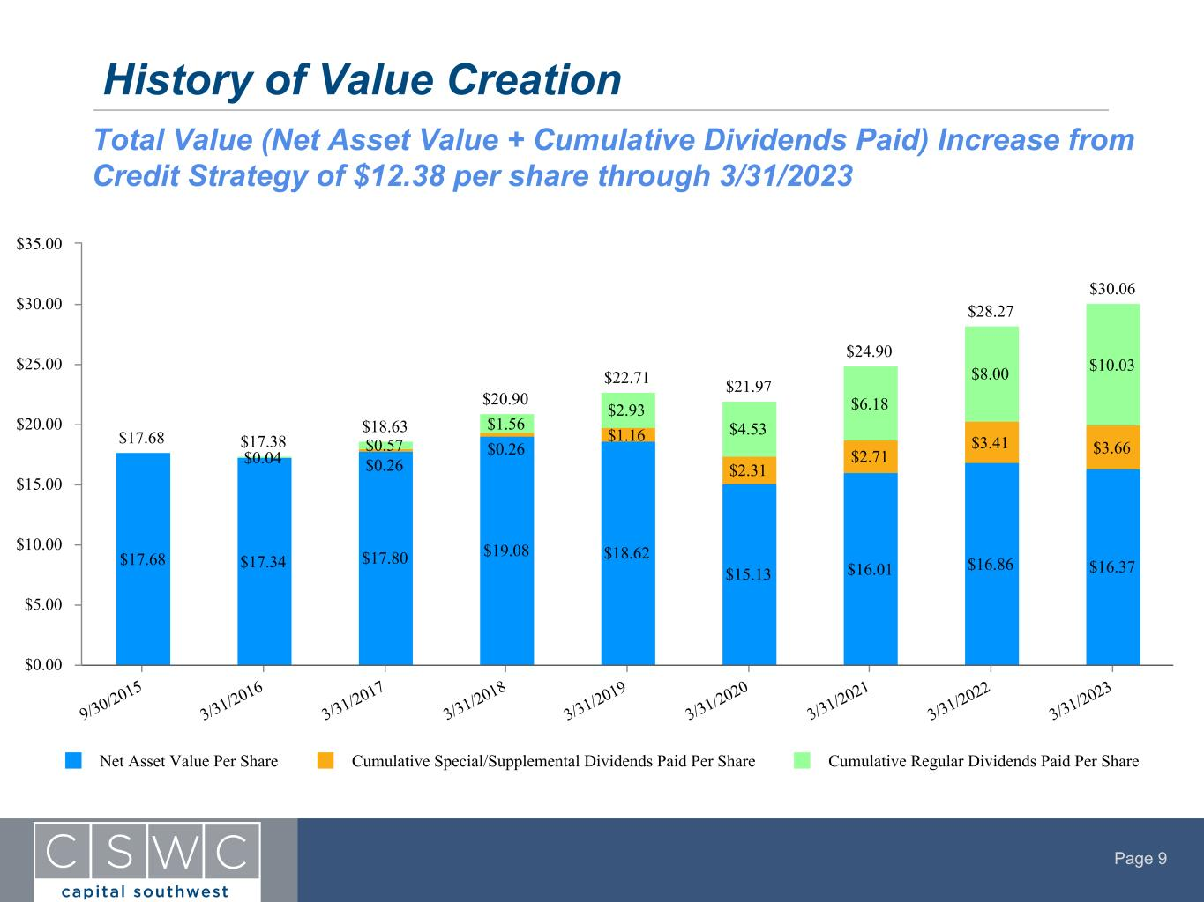
Page 9 History of Value Creation $17.68 $17.38 $18.63 $20.90 $22.71 $21.97 $24.90 $28.27 $30.06 $17.68 $17.34 $17.80 $19.08 $18.62 $15.13 $16.01 $16.86 $16.37 $0.26 $0.26 $1.16 $2.31 $2.71 $3.41 $3.66$0.04 $0.57 $1.56 $2.93 $4.53 $6.18 $8.00 $10.03 Net Asset Value Per Share Cumulative Special/Supplemental Dividends Paid Per Share Cumulative Regular Dividends Paid Per Share 9/30/2015 3/31/2016 3/31/2017 3/31/2018 3/31/2019 3/31/2020 3/31/2021 3/31/2022 3/31/2023 $0.00 $5.00 $10.00 $15.00 $20.00 $25.00 $30.00 $35.00 Total Value (Net Asset Value + Cumulative Dividends Paid) Increase from Credit Strategy of $12.38 per share through 3/31/2023

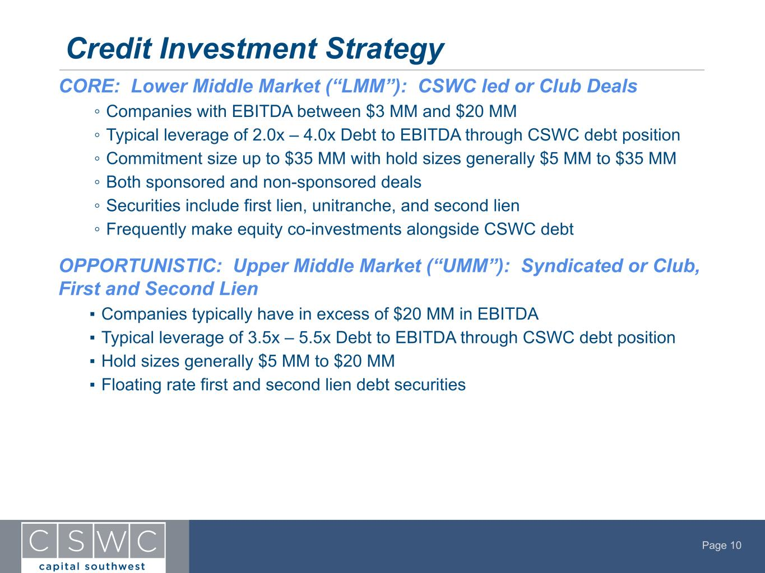
Page 10 CORE: Lower Middle Market (“LMM”): CSWC led or Club Deals ◦ Companies with EBITDA between $3 MM and $20 MM ◦ Typical leverage of 2.0x – 4.0x Debt to EBITDA through CSWC debt position ◦ Commitment size up to $35 MM with hold sizes generally $5 MM to $35 MM ◦ Both sponsored and non-sponsored deals ◦ Securities include first lien, unitranche, and second lien ◦ Frequently make equity co-investments alongside CSWC debt OPPORTUNISTIC: Upper Middle Market (“UMM”): Syndicated or Club, First and Second Lien ▪ Companies typically have in excess of $20 MM in EBITDA ▪ Typical leverage of 3.5x – 5.5x Debt to EBITDA through CSWC debt position ▪ Hold sizes generally $5 MM to $20 MM ▪ Floating rate first and second lien debt securities Credit Investment Strategy

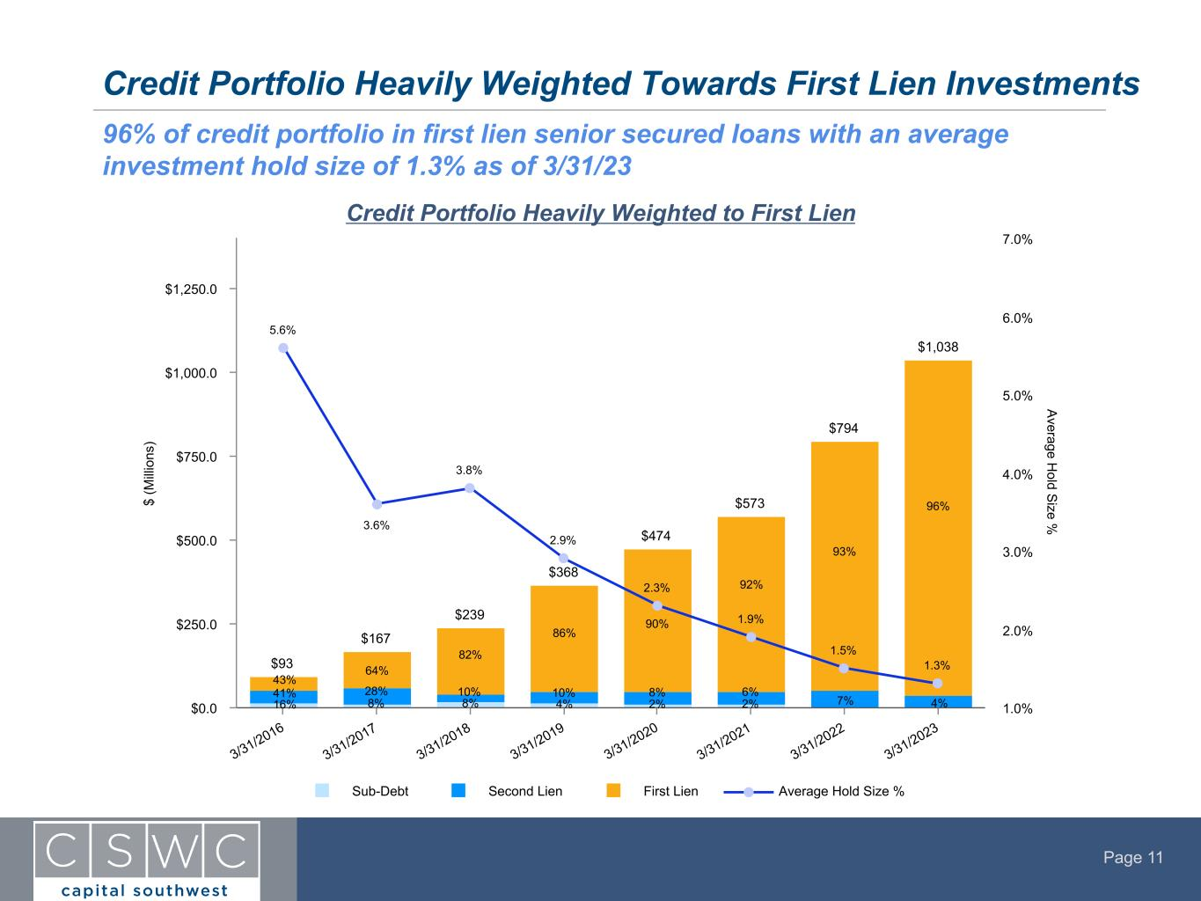
Page 11 Credit Portfolio Heavily Weighted Towards First Lien Investments 96% of credit portfolio in first lien senior secured loans with an average investment hold size of 1.3% as of 3/31/23 Credit Portfolio Heavily Weighted to First Lien $ (M ill io ns ) A verage H old S ize % $93 $167 $239 $368 $474 $573 $794 $1,038 5.6% 3.6% 3.8% 2.9% 2.3% 1.9% 1.5% 1.3% Sub-Debt Second Lien First Lien Average Hold Size % 3/31/2016 3/31/2017 3/31/2018 3/31/2019 3/31/2020 3/31/2021 3/31/2022 3/31/2023 $0.0 $250.0 $500.0 $750.0 $1,000.0 $1,250.0 1.0% 2.0% 3.0% 4.0% 5.0% 6.0% 7.0% 64% 28% 8% 82% 10% 8% 4% 10% 86% 90% 8% 2% 6% 92% 2% 93% 7% 96% 4% 43% 41% 16%

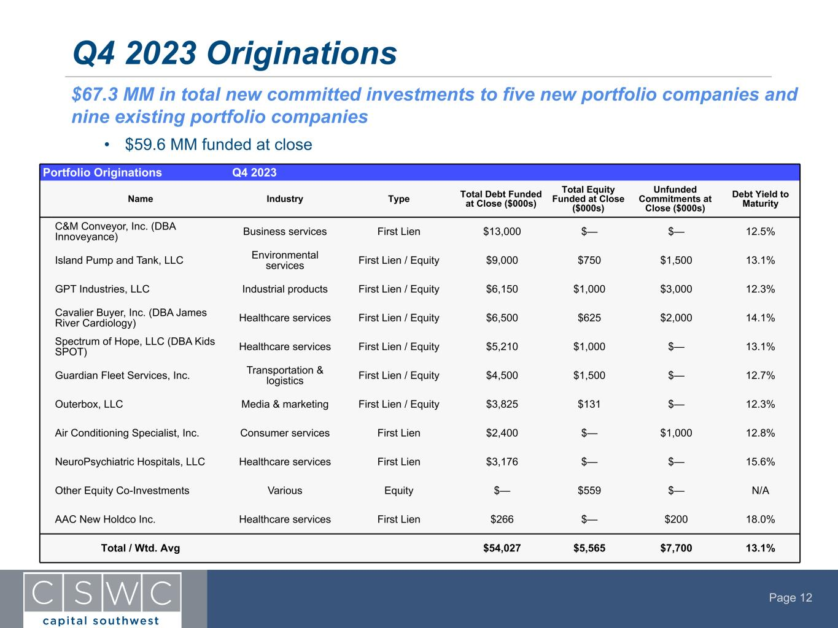
Page 12 $67.3 MM in total new committed investments to five new portfolio companies and nine existing portfolio companies Q4 2023 Originations Portfolio Originations Q4 2023 Name Industry Type Total Debt Funded at Close ($000s) Total Equity Funded at Close ($000s) Unfunded Commitments at Close ($000s) Debt Yield to Maturity C&M Conveyor, Inc. (DBA Innoveyance) Business services First Lien $13,000 $— $— 12.5% Island Pump and Tank, LLC Environmental services First Lien / Equity $9,000 $750 $1,500 13.1% GPT Industries, LLC Industrial products First Lien / Equity $6,150 $1,000 $3,000 12.3% Cavalier Buyer, Inc. (DBA James River Cardiology) Healthcare services First Lien / Equity $6,500 $625 $2,000 14.1% Spectrum of Hope, LLC (DBA Kids SPOT) Healthcare services First Lien / Equity $5,210 $1,000 $— 13.1% Guardian Fleet Services, Inc. Transportation & logistics First Lien / Equity $4,500 $1,500 $— 12.7% Outerbox, LLC Media & marketing First Lien / Equity $3,825 $131 $— 12.3% Air Conditioning Specialist, Inc. Consumer services First Lien $2,400 $— $1,000 12.8% NeuroPsychiatric Hospitals, LLC Healthcare services First Lien $3,176 $— $— 15.6% Other Equity Co-Investments Various Equity $— $559 $— N/A AAC New Holdco Inc. Healthcare services First Lien $266 $— $200 18.0% Total / Wtd. Avg $54,027 $5,565 $7,700 13.1% • $59.6 MM funded at close

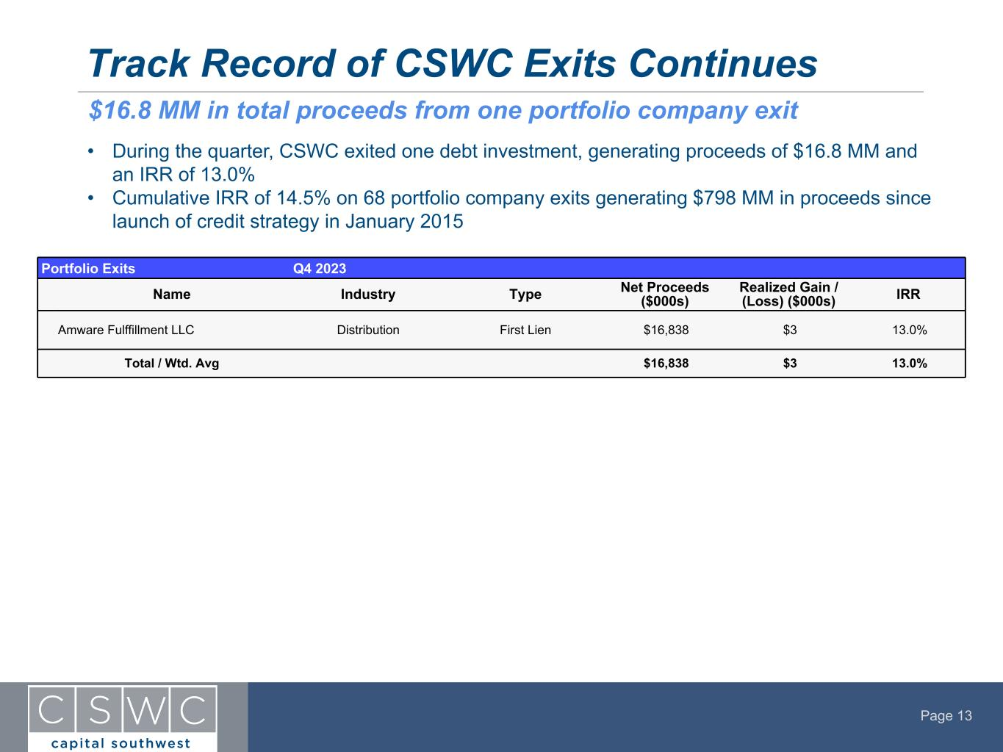
Page 13 Portfolio Exits Q4 2023 Name Industry Type Net Proceeds ($000s) Realized Gain / (Loss) ($000s) IRR Amware Fulffillment LLC Distribution First Lien $16,838 $3 13.0% Total / Wtd. Avg $16,838 $3 13.0% Track Record of CSWC Exits Continues • During the quarter, CSWC exited one debt investment, generating proceeds of $16.8 MM and an IRR of 13.0% • Cumulative IRR of 14.5% on 68 portfolio company exits generating $798 MM in proceeds since launch of credit strategy in January 2015 $16.8 MM in total proceeds from one portfolio company exit

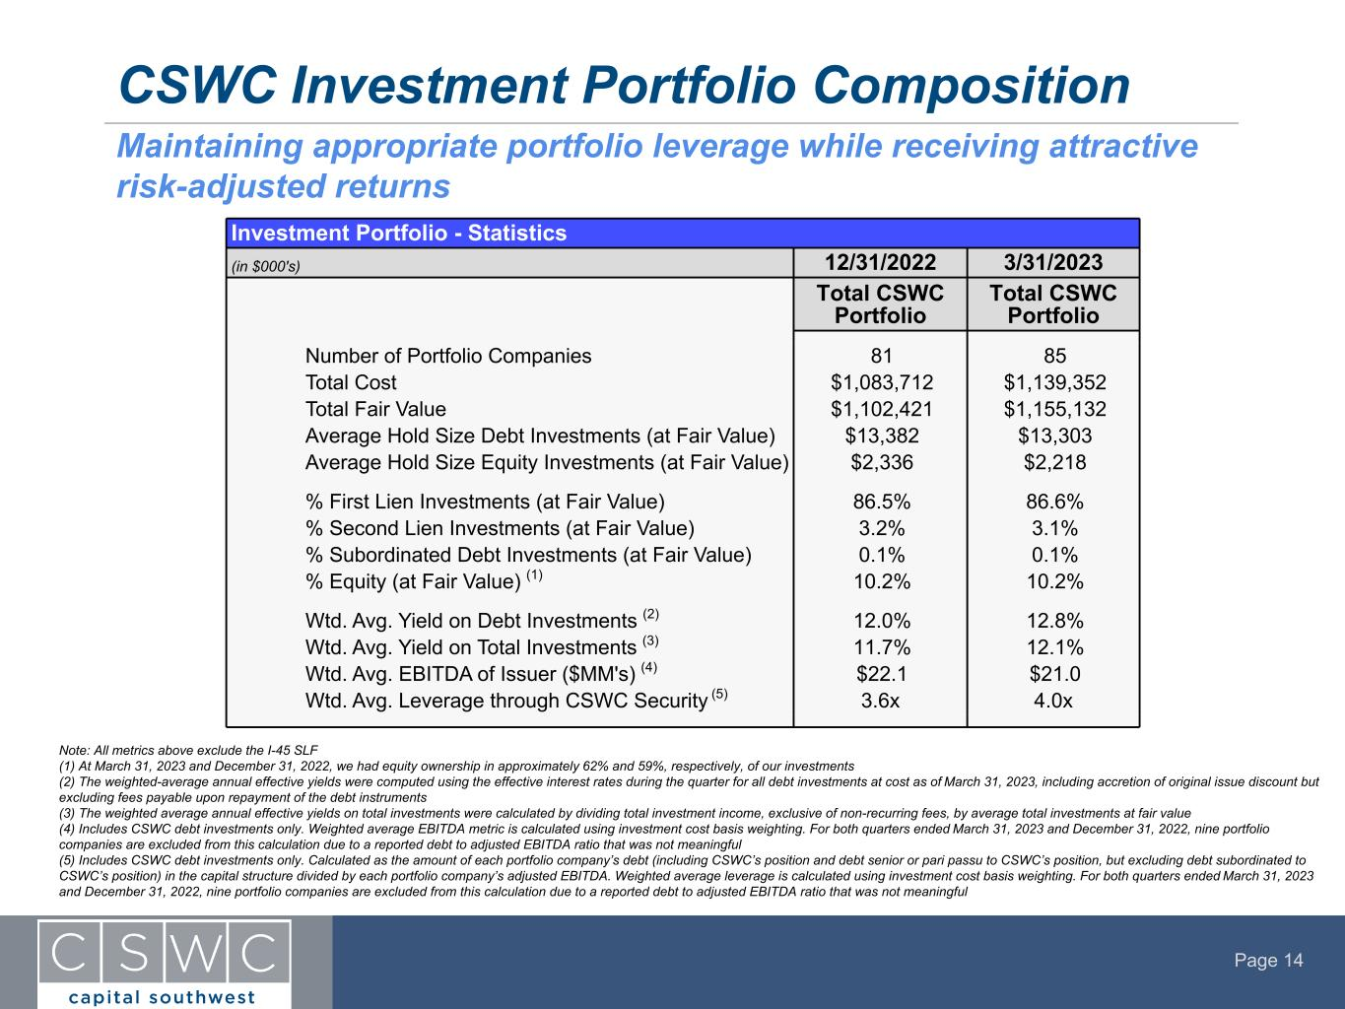
Page 14 CSWC Investment Portfolio Composition Note: All metrics above exclude the I-45 SLF (1) At March 31, 2023 and December 31, 2022, we had equity ownership in approximately 62% and 59%, respectively, of our investments (2) The weighted-average annual effective yields were computed using the effective interest rates during the quarter for all debt investments at cost as of March 31, 2023, including accretion of original issue discount but excluding fees payable upon repayment of the debt instruments (3) The weighted average annual effective yields on total investments were calculated by dividing total investment income, exclusive of non-recurring fees, by average total investments at fair value (4) Includes CSWC debt investments only. Weighted average EBITDA metric is calculated using investment cost basis weighting. For both quarters ended March 31, 2023 and December 31, 2022, nine portfolio companies are excluded from this calculation due to a reported debt to adjusted EBITDA ratio that was not meaningful (5) Includes CSWC debt investments only. Calculated as the amount of each portfolio company’s debt (including CSWC’s position and debt senior or pari passu to CSWC’s position, but excluding debt subordinated to CSWC’s position) in the capital structure divided by each portfolio company’s adjusted EBITDA. Weighted average leverage is calculated using investment cost basis weighting. For both quarters ended March 31, 2023 and December 31, 2022, nine portfolio companies are excluded from this calculation due to a reported debt to adjusted EBITDA ratio that was not meaningful Maintaining appropriate portfolio leverage while receiving attractive risk-adjusted returns Investment Portfolio - Statistics (in $000's) 12/31/2022 3/31/2023 Total CSWC Portfolio Total CSWC Portfolio Number of Portfolio Companies 81 85 Total Cost $1,083,712 $1,139,352 Total Fair Value $1,102,421 $1,155,132 Average Hold Size Debt Investments (at Fair Value) $13,382 $13,303 Average Hold Size Equity Investments (at Fair Value) $2,336 $2,218 % First Lien Investments (at Fair Value) 86.5% 86.6% % Second Lien Investments (at Fair Value) 3.2% 3.1% % Subordinated Debt Investments (at Fair Value) 0.1% 0.1% % Equity (at Fair Value) (1) 10.2% 10.2% Wtd. Avg. Yield on Debt Investments (2) 12.0% 12.8% Wtd. Avg. Yield on Total Investments (3) 11.7% 12.1% Wtd. Avg. EBITDA of Issuer ($MM's) (4) $22.1 $21.0 Wtd. Avg. Leverage through CSWC Security (5) 3.6x 4.0x

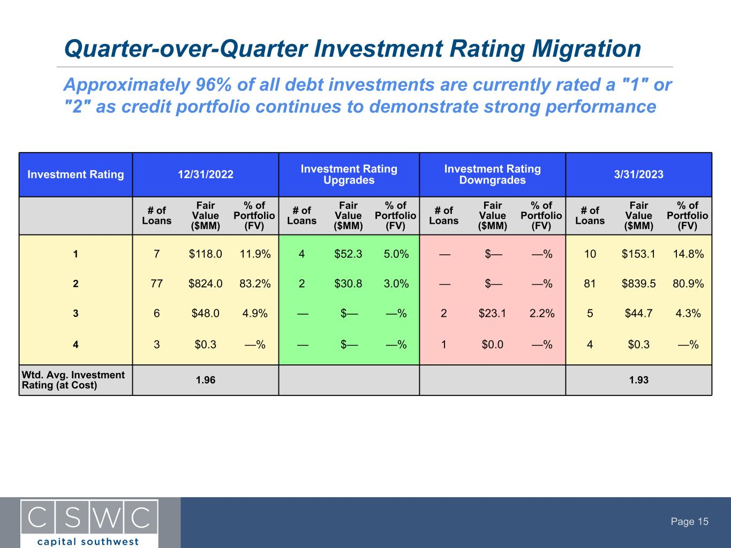
Page 15 Approximately 96% of all debt investments are currently rated a "1" or "2" as credit portfolio continues to demonstrate strong performance Investment Rating 12/31/2022 Investment Rating Upgrades Investment Rating Downgrades 3/31/2023 # of Loans Fair Value ($MM) % of Portfolio (FV) # of Loans Fair Value ($MM) % of Portfolio (FV) # of Loans Fair Value ($MM) % of Portfolio (FV) # of Loans Fair Value ($MM) % of Portfolio (FV) 1 7 $118.0 11.9% 4 $52.3 5.0% — $— —% 10 $153.1 14.8% 2 77 $824.0 83.2% 2 $30.8 3.0% — $— —% 81 $839.5 80.9% 3 6 $48.0 4.9% — $— —% 2 $23.1 2.2% 5 $44.7 4.3% 4 3 $0.3 —% — $— —% 1 $0.0 —% 4 $0.3 —% Wtd. Avg. Investment Rating (at Cost) 1.96 1.93 Quarter-over-Quarter Investment Rating Migration

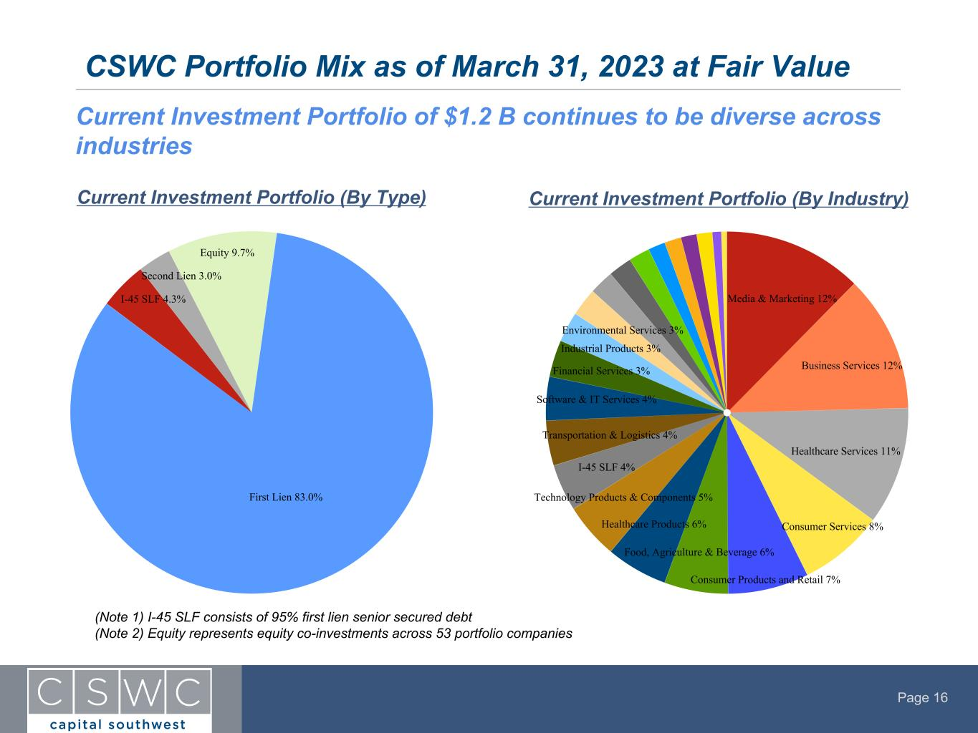
Page 16 CSWC Portfolio Mix as of March 31, 2023 at Fair Value Current Investment Portfolio (By Type) Current Investment Portfolio (By Industry) Current Investment Portfolio of $1.2 B continues to be diverse across industries First Lien 83.0% I-45 SLF 4.3% Second Lien 3.0% Equity 9.7% Media & Marketing 12% Business Services 12% Healthcare Services 11% Consumer Services 8% Consumer Products and Retail 7% Food, Agriculture & Beverage 6% Healthcare Products 6% Technology Products & Components 5% I-45 SLF 4% Transportation & Logistics 4% Software & IT Services 4% Financial Services 3% Industrial Products 3% Environmental Services 3% (Note 1) I-45 SLF consists of 95% first lien senior secured debt (Note 2) Equity represents equity co-investments across 53 portfolio companies

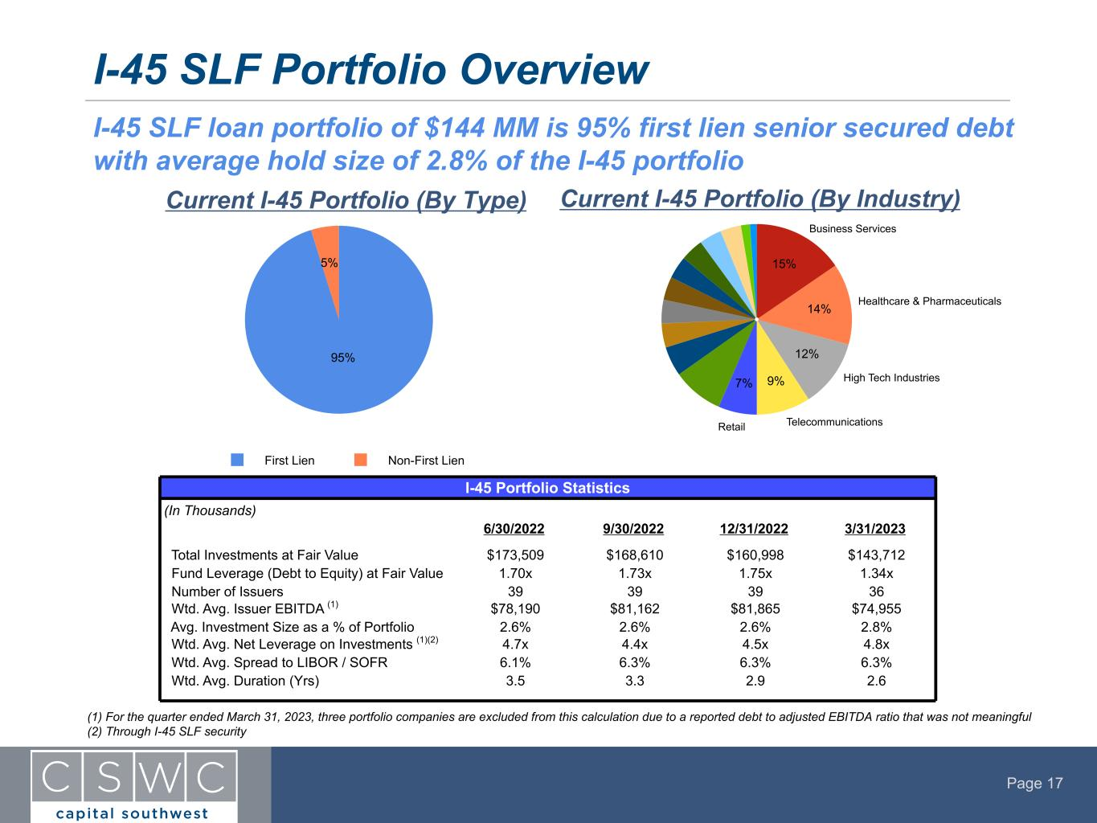
Page 17 I-45 SLF Portfolio Overview Current I-45 Portfolio (By Industry) I-45 SLF loan portfolio of $144 MM is 95% first lien senior secured debt with average hold size of 2.8% of the I-45 portfolio (1) For the quarter ended March 31, 2023, three portfolio companies are excluded from this calculation due to a reported debt to adjusted EBITDA ratio that was not meaningful (2) Through I-45 SLF security Telecommunications Services: Consumer Current I-45 Portfolio (By Type) I-45 Portfolio Statistics (In Thousands) 6/30/2022 9/30/2022 12/31/2022 3/31/2023 Total Investments at Fair Value $173,509 $168,610 $160,998 $143,712 Fund Leverage (Debt to Equity) at Fair Value 1.70x 1.73x 1.75x 1.34x Number of Issuers 39 39 39 36 Wtd. Avg. Issuer EBITDA (1) $78,190 $81,162 $81,865 $74,955 Avg. Investment Size as a % of Portfolio 2.6% 2.6% 2.6% 2.8% Wtd. Avg. Net Leverage on Investments (1)(2) 4.7x 4.4x 4.5x 4.8x Wtd. Avg. Spread to LIBOR / SOFR 6.1% 6.3% 6.3% 6.3% Wtd. Avg. Duration (Yrs) 3.5 3.3 2.9 2.6 95% 5% First Lien Non-First Lien Telecommunications Healthcare & Pharmaceuticals High Tech Industries Business Services 15% 14% 12% 9%7% Retail

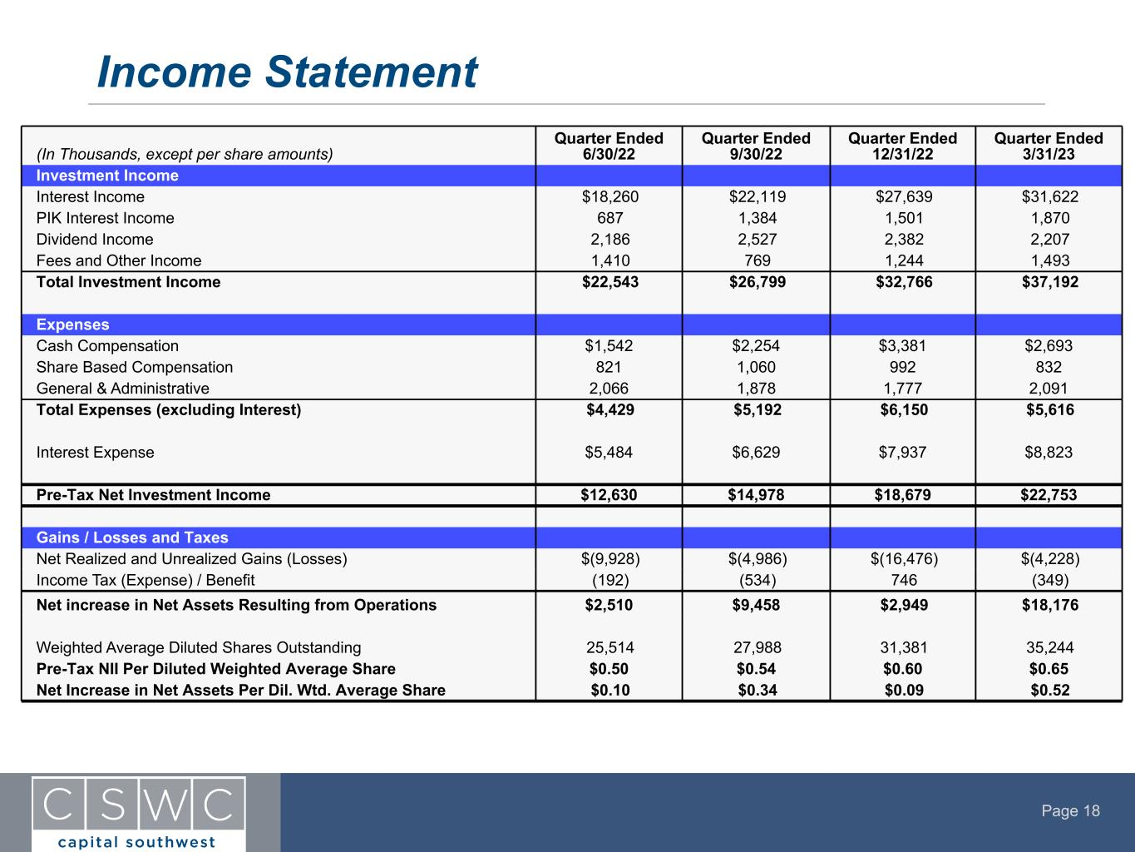
Page 18 Income Statement (In Thousands, except per share amounts) Quarter Ended 6/30/22 Quarter Ended 9/30/22 Quarter Ended 12/31/22 Quarter Ended 3/31/23 Investment Income Interest Income $18,260 $22,119 $27,639 $31,622 PIK Interest Income 687 1,384 1,501 1,870 Dividend Income 2,186 2,527 2,382 2,207 Fees and Other Income 1,410 769 1,244 1,493 Total Investment Income $22,543 $26,799 $32,766 $37,192 Expenses Cash Compensation $1,542 $2,254 $3,381 $2,693 Share Based Compensation 821 1,060 992 832 General & Administrative 2,066 1,878 1,777 2,091 Total Expenses (excluding Interest) $4,429 $5,192 $6,150 $5,616 Interest Expense $5,484 $6,629 $7,937 $8,823 Pre-Tax Net Investment Income $12,630 $14,978 $18,679 $22,753 Gains / Losses and Taxes Net Realized and Unrealized Gains (Losses) $(9,928) $(4,986) $(16,476) $(4,228) Income Tax (Expense) / Benefit (192) (534) 746 (349) Net increase in Net Assets Resulting from Operations $2,510 $9,458 $2,949 $18,176 Weighted Average Diluted Shares Outstanding 25,514 27,988 31,381 35,244 Pre-Tax NII Per Diluted Weighted Average Share $0.50 $0.54 $0.60 $0.65 Net Increase in Net Assets Per Dil. Wtd. Average Share $0.10 $0.34 $0.09 $0.52

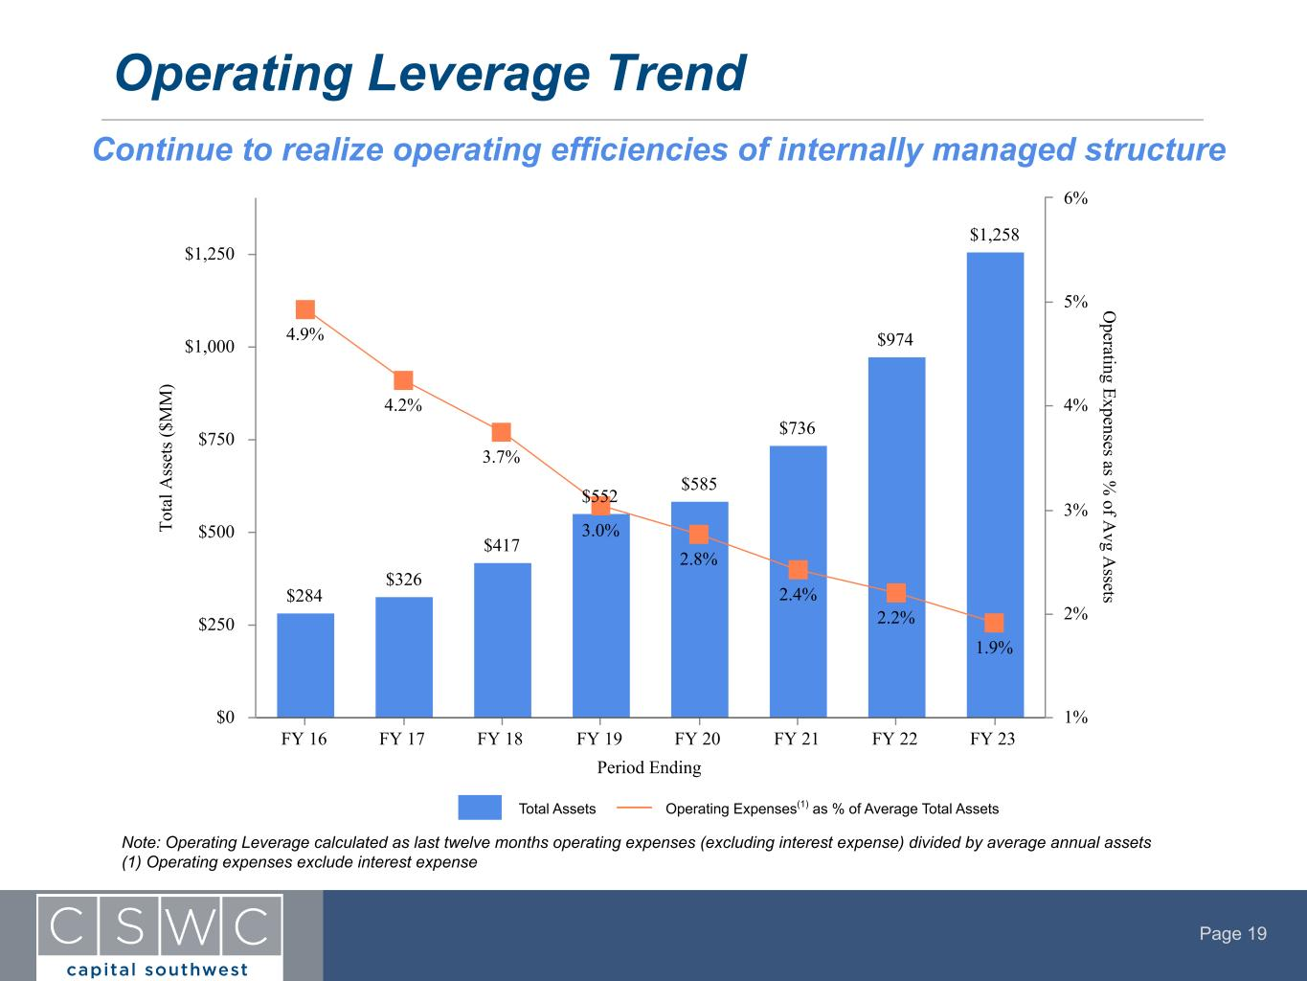
Page 19 Operating Leverage Trend Continue to realize operating efficiencies of internally managed structure Period Ending To ta l A ss et s ( $M M ) O perating Expenses as % of A vg A ssets$284 $326 $417 $552 $585 $736 $974 $1,258 4.9% 4.2% 3.7% 3.0% 2.8% 2.4% 2.2% 1.9% FY 16 FY 17 FY 18 FY 19 FY 20 FY 21 FY 22 FY 23 $0 $250 $500 $750 $1,000 $1,250 1% 2% 3% 4% 5% 6% Total Assets Operating Expenses(1) as % of Average Total Assets Note: Operating Leverage calculated as last twelve months operating expenses (excluding interest expense) divided by average annual assets (1) Operating expenses exclude interest expense

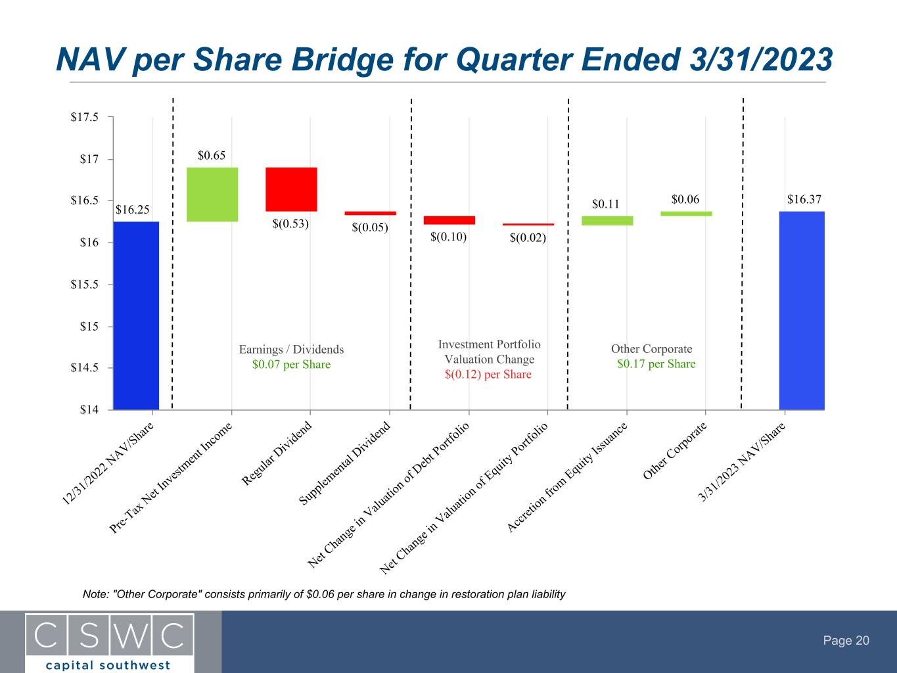
Page 20 $16.25 $0.65 $(0.53) $(0.05) $(0.10) $(0.02) $0.11 $0.06 $16.37 12 /31 /20 22 NAV/Shar e Pre- Tax Net I nv est ment In com e Regu lar Divi den d Sup ple ment al D ivi den d Net C han ge in Valu ati on of Debt Port fol io Net C han ge in Valu ati on of Equ ity Port fol io Accr eti on fro m Equ ity Iss uan ce Othe r C orp ora te 3/3 1/2 02 3 N AV/Shar e $14 $14.5 $15 $15.5 $16 $16.5 $17 $17.5 NAV per Share Bridge for Quarter Ended 3/31/2023 Earnings / Dividends $0.07 per Share Investment Portfolio Valuation Change $(0.12) per Share Other Corporate $0.17 per Share Note: "Other Corporate" consists primarily of $0.06 per share in change in restoration plan liability

Page 21 Significant Unused Debt Capacity with Long-Term Duration Earliest debt maturity occurs in January 2026 Facility Total Commitments Interest Rate Maturity Principal Drawn Undrawn Commitment January 2026 Notes (1) $140.0 MM 4.50% January 2026 $140.0 MM N/A I-45 Credit Facility (2) $100.0 MM Term SOFR + 2.41% March 2026 $86.0 MM $14.0 MM Credit Facility $400.0 MM Term SOFR + 2.15% (3) August 2026 $235.0 MM $164.4 MM (4) October 2026 Notes (5) $150.0 MM 3.375% October 2026 $150.0 MM N/A SBA Debentures $130.0 MM 4.08% (6) September 2031 (7) $120.0 MM $10.0 MM (8) P rin ci pa l P ay m en ts ($ M M ) Long-Term Debt Obligations (Calendar Year) $611.0 $15.0 $65.0 $40.0 140.0 86.0 235.0 150.0 January 2026 Notes I-45 Credit Facility Credit Facility October 2026 Notes SBA Debentures CY 2023 CY 2024 CY 2025 CY 2026 CY 2027 - CY 2030 CY 2031 CY 2032 CY 2033 $0 $100 $200 $300 $400 $500 $600 $700 (1) Redeemable in whole or in part at any time prior to October 31, 2025, at par plus a "make whole" premium, and thereafter at par (2) CSWC owns 80% of the equity and 50% of the voting rights of I-45 SLF with a joint venture partner (3) Additional 0.10% adjustment for 1-month SOFR loans, and 0.15% adjustment for 3-month SOFR loans (4) Net of $0.6 MM in letters of credit outstanding (5) Redeemable in whole or in part at any time prior to July 1, 2026, at par plus a "make whole" premium, and thereafter at par (6) Weighted average interest rate of all pooled and unpooled SBA Debentures for the three months ended March 31, 2023 (7) First pooled SBA Debentures mature on September 1, 2031 (8) Current statutes and regulations permit SBIC I to borrow up to $175 million in SBA Debentures with at least $87.5 million in regulatory capital, subject to SBA approval

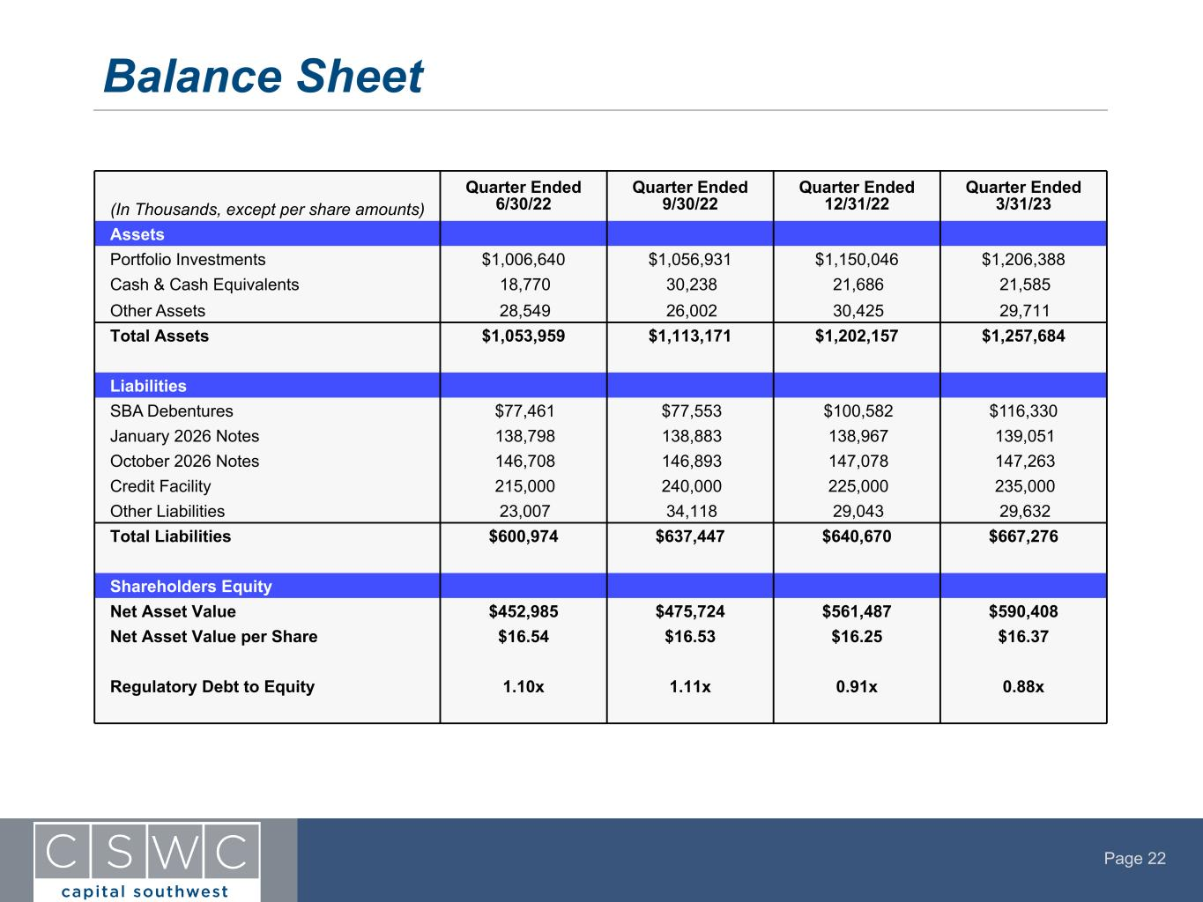
Page 22 Balance Sheet (In Thousands, except per share amounts) Quarter Ended 6/30/22 Quarter Ended 9/30/22 Quarter Ended 12/31/22 Quarter Ended 3/31/23 Assets Portfolio Investments $1,006,640 $1,056,931 $1,150,046 $1,206,388 Cash & Cash Equivalents 18,770 30,238 21,686 21,585 Other Assets 28,549 26,002 30,425 29,711 Total Assets $1,053,959 $1,113,171 $1,202,157 $1,257,684 Liabilities SBA Debentures $77,461 $77,553 $100,582 $116,330 January 2026 Notes 138,798 138,883 138,967 139,051 October 2026 Notes 146,708 146,893 147,078 147,263 Credit Facility 215,000 240,000 225,000 235,000 Other Liabilities 23,007 34,118 29,043 29,632 Total Liabilities $600,974 $637,447 $640,670 $667,276 Shareholders Equity Net Asset Value $452,985 $475,724 $561,487 $590,408 Net Asset Value per Share $16.54 $16.53 $16.25 $16.37 Regulatory Debt to Equity 1.10x 1.11x 0.91x 0.88x

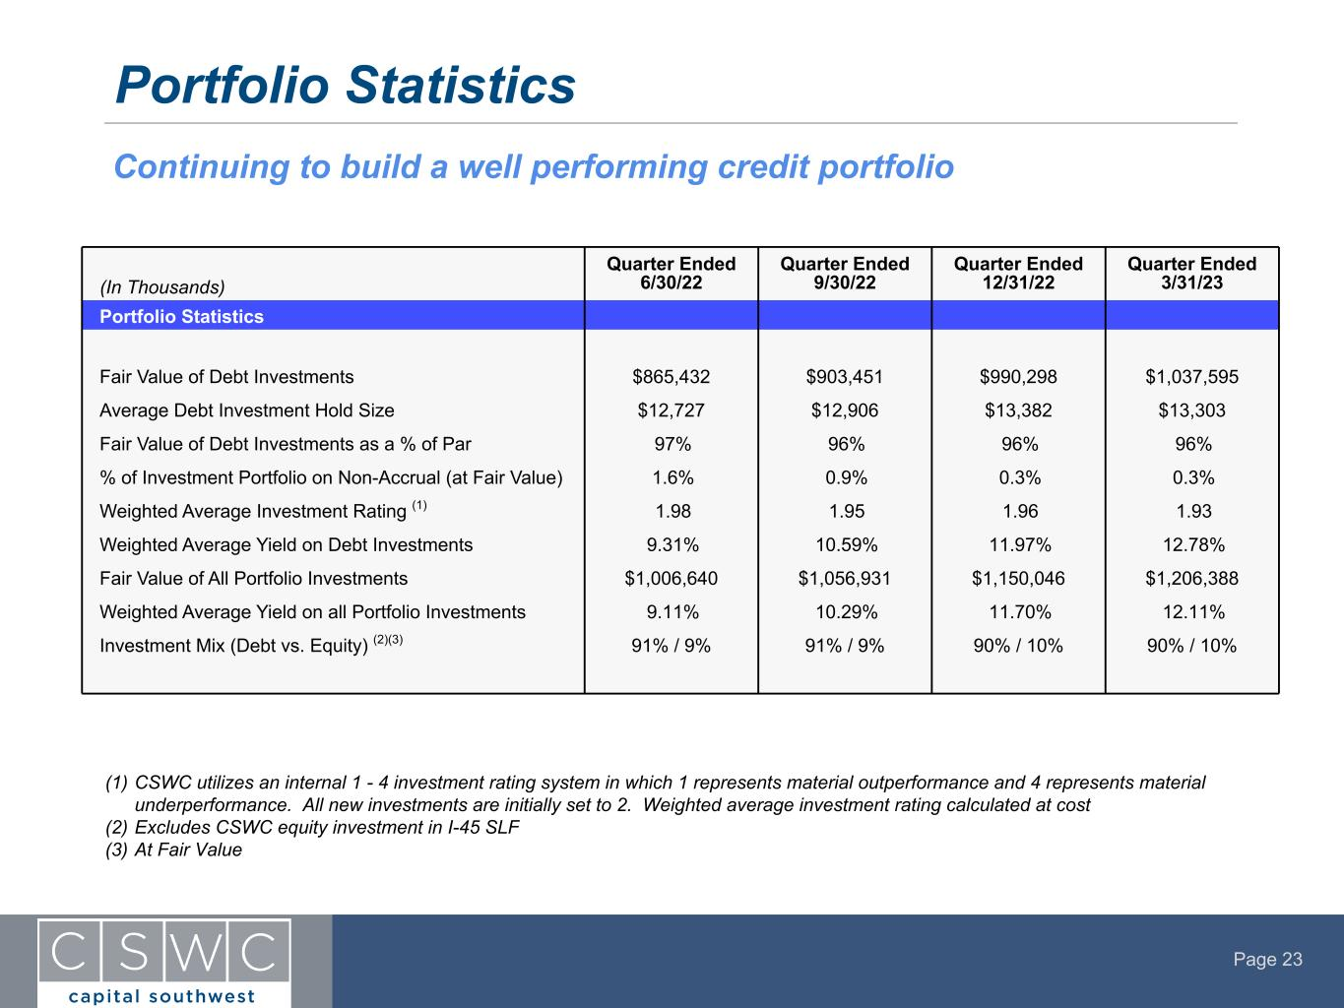
Page 23 Portfolio Statistics (1) CSWC utilizes an internal 1 - 4 investment rating system in which 1 represents material outperformance and 4 represents material underperformance. All new investments are initially set to 2. Weighted average investment rating calculated at cost (2) Excludes CSWC equity investment in I-45 SLF (3) At Fair Value Continuing to build a well performing credit portfolio (In Thousands) Quarter Ended 6/30/22 Quarter Ended 9/30/22 Quarter Ended 12/31/22 Quarter Ended 3/31/23 Portfolio Statistics Fair Value of Debt Investments $865,432 $903,451 $990,298 $1,037,595 Average Debt Investment Hold Size $12,727 $12,906 $13,382 $13,303 Fair Value of Debt Investments as a % of Par 97% 96% 96% 96% % of Investment Portfolio on Non-Accrual (at Fair Value) 1.6% 0.9% 0.3% 0.3% Weighted Average Investment Rating (1) 1.98 1.95 1.96 1.93 Weighted Average Yield on Debt Investments 9.31% 10.59% 11.97% 12.78% Fair Value of All Portfolio Investments $1,006,640 $1,056,931 $1,150,046 $1,206,388 Weighted Average Yield on all Portfolio Investments 9.11% 10.29% 11.70% 12.11% Investment Mix (Debt vs. Equity) (2)(3) 91% / 9% 91% / 9% 90% / 10% 90% / 10%

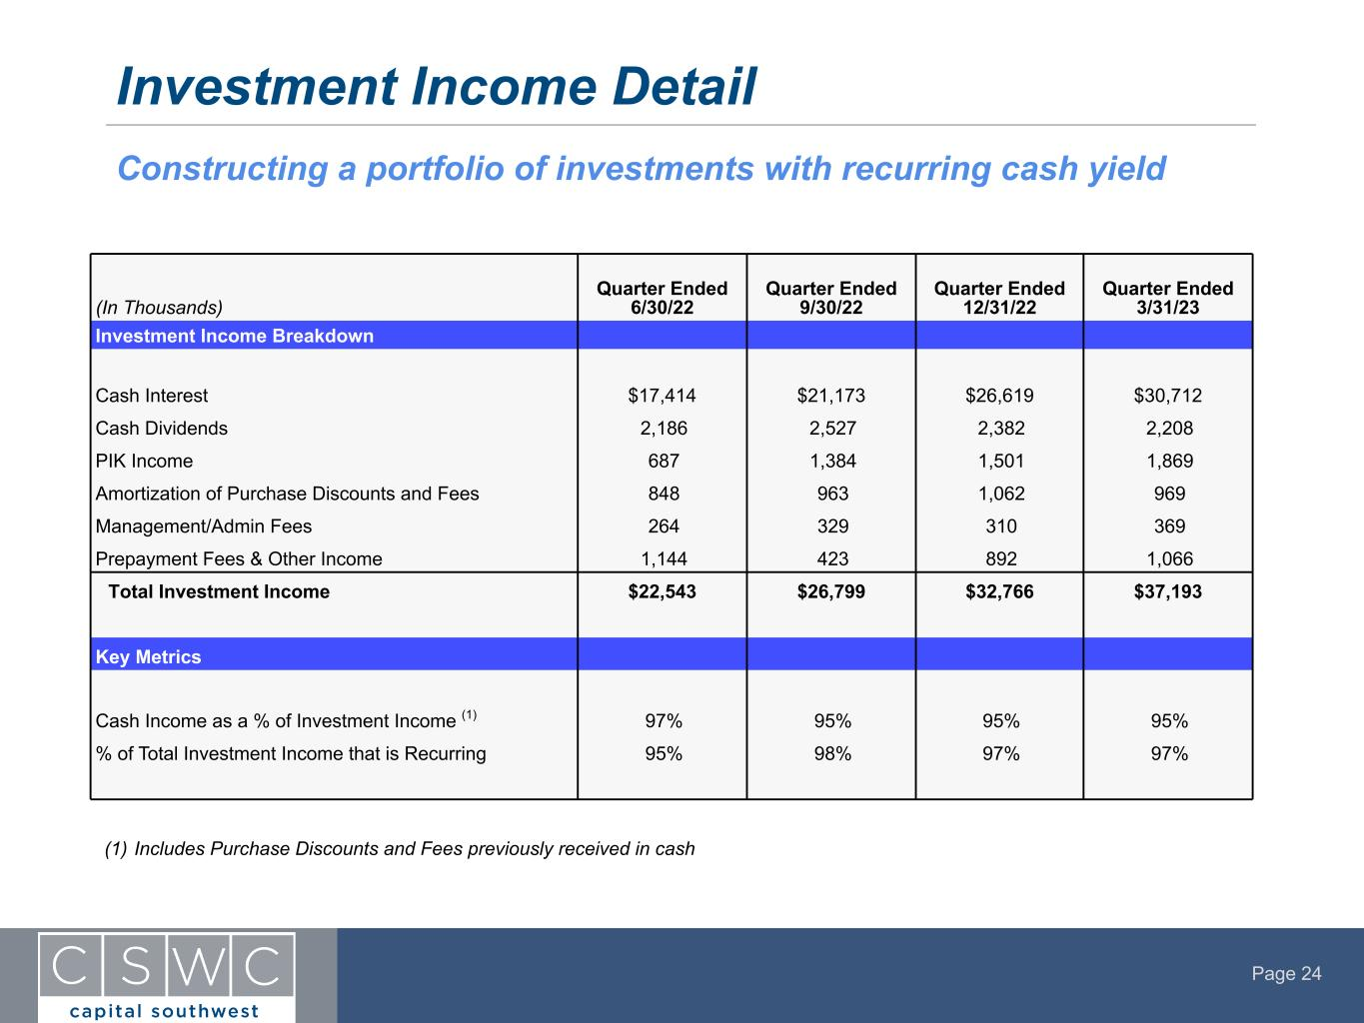
Page 24 Investment Income Detail Constructing a portfolio of investments with recurring cash yield (In Thousands) Quarter Ended 6/30/22 Quarter Ended 9/30/22 Quarter Ended 12/31/22 Quarter Ended 3/31/23 Investment Income Breakdown Cash Interest $17,414 $21,173 $26,619 $30,712 Cash Dividends 2,186 2,527 2,382 2,208 PIK Income 687 1,384 1,501 1,869 Amortization of Purchase Discounts and Fees 848 963 1,062 969 Management/Admin Fees 264 329 310 369 Prepayment Fees & Other Income 1,144 423 892 1,066 Total Investment Income $22,543 $26,799 $32,766 $37,193 Key Metrics Cash Income as a % of Investment Income (1) 97% 95% 95% 95% % of Total Investment Income that is Recurring 95% 98% 97% 97% (1) Includes Purchase Discounts and Fees previously received in cash

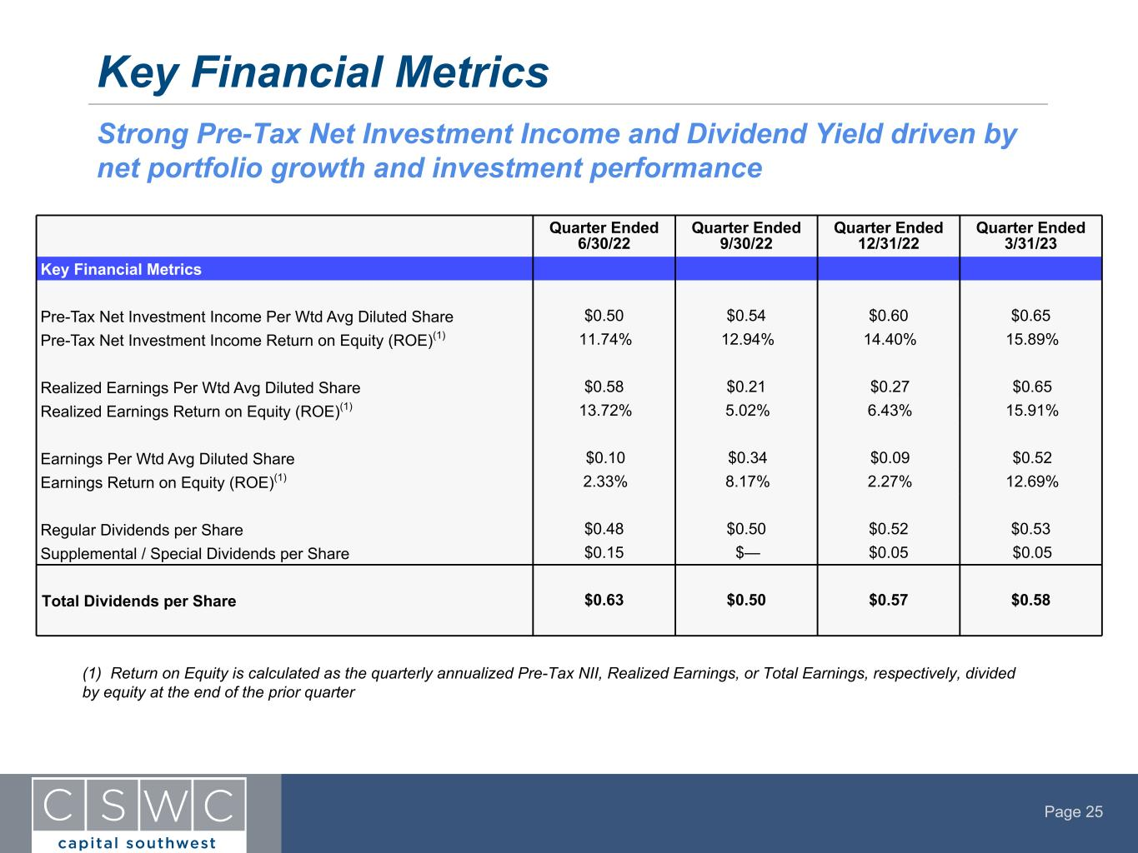
Page 25 Key Financial Metrics Strong Pre-Tax Net Investment Income and Dividend Yield driven by net portfolio growth and investment performance (1) Return on Equity is calculated as the quarterly annualized Pre-Tax NII, Realized Earnings, or Total Earnings, respectively, divided by equity at the end of the prior quarter Quarter Ended 6/30/22 Quarter Ended 9/30/22 Quarter Ended 12/31/22 Quarter Ended 3/31/23 Key Financial Metrics Pre-Tax Net Investment Income Per Wtd Avg Diluted Share $0.50 $0.54 $0.60 $0.65 Pre-Tax Net Investment Income Return on Equity (ROE)(1) 11.74% 12.94% 14.40% 15.89% Realized Earnings Per Wtd Avg Diluted Share $0.58 $0.21 $0.27 $0.65 Realized Earnings Return on Equity (ROE)(1) 13.72% 5.02% 6.43% 15.91% Earnings Per Wtd Avg Diluted Share $0.10 $0.34 $0.09 $0.52 Earnings Return on Equity (ROE)(1) 2.33% 8.17% 2.27% 12.69% Regular Dividends per Share $0.48 $0.50 $0.52 $0.53 Supplemental / Special Dividends per Share $0.15 $— $0.05 $0.05 Total Dividends per Share $0.63 $0.50 $0.57 $0.58

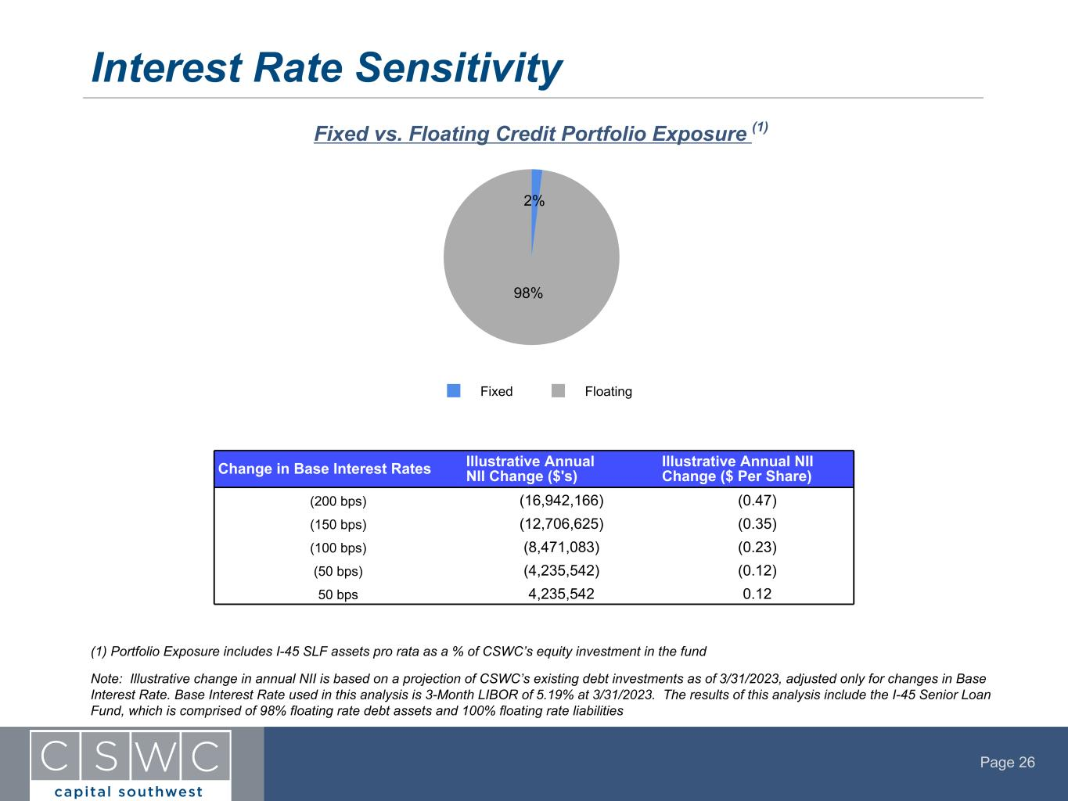
Page 26 Interest Rate Sensitivity Fixed vs. Floating Credit Portfolio Exposure (1) Note: Illustrative change in annual NII is based on a projection of CSWC’s existing debt investments as of 3/31/2023, adjusted only for changes in Base Interest Rate. Base Interest Rate used in this analysis is 3-Month LIBOR of 5.19% at 3/31/2023. The results of this analysis include the I-45 Senior Loan Fund, which is comprised of 98% floating rate debt assets and 100% floating rate liabilities (1) Portfolio Exposure includes I-45 SLF assets pro rata as a % of CSWC’s equity investment in the fund Change in Base Interest Rates Illustrative Annual NII Change ($'s) Illustrative Annual NII Change ($ Per Share) (200 bps) (16,942,166) (0.47) (150 bps) (12,706,625) (0.35) (100 bps) (8,471,083) (0.23) (50 bps) (4,235,542) (0.12) 50 bps 4,235,542 0.12 2% 98% Fixed Floating

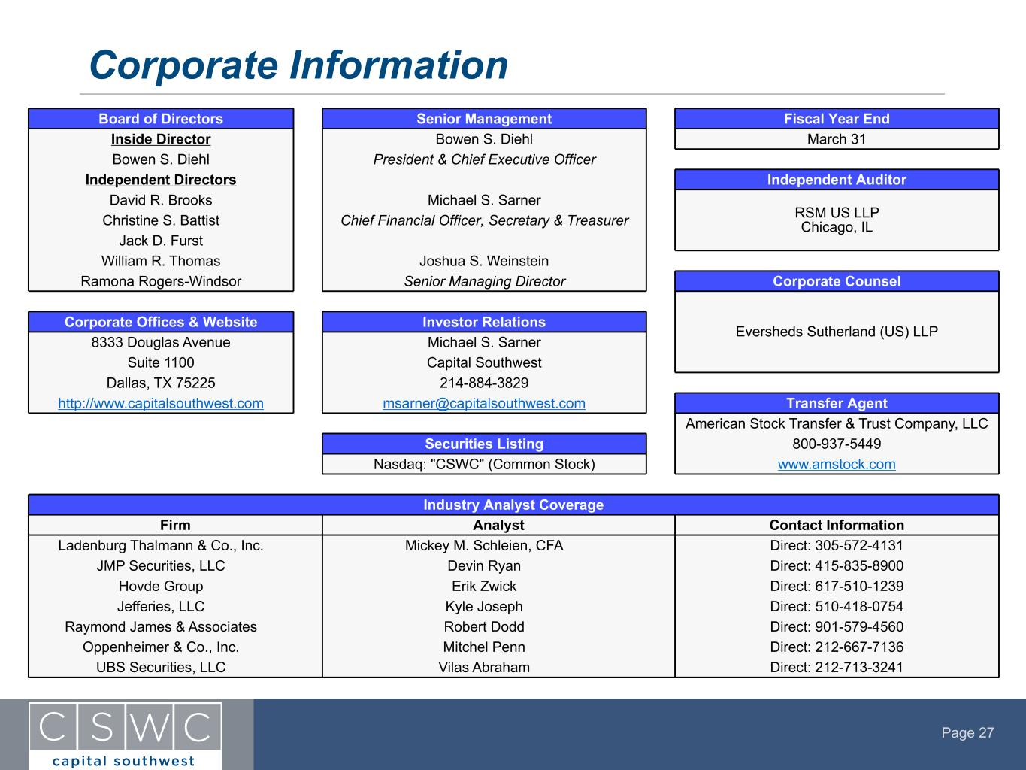
Page 27 Corporate Information Board of Directors Senior Management Fiscal Year End Inside Director Bowen S. Diehl March 31 Bowen S. Diehl President & Chief Executive Officer Independent Directors Independent Auditor David R. Brooks Michael S. Sarner RSM US LLP Chicago, ILChristine S. Battist Chief Financial Officer, Secretary & Treasurer Jack D. Furst William R. Thomas Joshua S. Weinstein Ramona Rogers-Windsor Senior Managing Director Corporate Counsel Eversheds Sutherland (US) LLP Corporate Offices & Website Investor Relations 8333 Douglas Avenue Michael S. Sarner Suite 1100 Capital Southwest Dallas, TX 75225 214-884-3829 http://www.capitalsouthwest.com msarner@capitalsouthwest.com Transfer Agent American Stock Transfer & Trust Company, LLC Securities Listing 800-937-5449 Nasdaq: "CSWC" (Common Stock) www.amstock.com Industry Analyst Coverage Firm Analyst Contact Information Ladenburg Thalmann & Co., Inc. Mickey M. Schleien, CFA Direct: 305-572-4131 JMP Securities, LLC Devin Ryan Direct: 415-835-8900 Hovde Group Erik Zwick Direct: 617-510-1239 Jefferies, LLC Kyle Joseph Direct: 510-418-0754 Raymond James & Associates Robert Dodd Direct: 901-579-4560 Oppenheimer & Co., Inc. Mitchel Penn Direct: 212-667-7136 UBS Securities, LLC Vilas Abraham Direct: 212-713-3241

