UNITED STATES
SECURITIES AND EXCHANGE COMMISSION
WASHINGTON, D.C. 20549

SCHEDULE 14A

Proxy Statement Pursuant to Section 14(a) of the
Securities Exchange Act of 1934 (Amendment No. )
Filed by the Registrant ☒
Filed by a Party other than the Registrant o
Check the appropriate box:
o |  |  |  |  |  | Preliminary Proxy Statement
o |  |  |  |  |  | Confidential, For Use of the Commission Only (as permitted by Rule 14a-6(e)(2))
o |  |  |  |  |  | Definitive Proxy Statement
☒ |  |  |  |  |  | Definitive Additional Materials
o |  |  |  |  |  | Soliciting Material Pursuant to Rule 14a-11(c) or Rule 14a-12
CAPITAL SOUTHWEST CORPORATION
(Name of Registrant as Specified In Its Charter)
(Name of Person(s) Filing Proxy Statement, if Other Than the Registrant)
Payment of Filing Fee (Check the appropriate box):
☒ |  |  |  |  |  | No fee required.
o |  |  |  |  |  | Fee paid previously with preliminary materials.
o |  |  |  |  |  | Fee computed on table in exhibit required by Item 25(b) per Exchange Act Rules 14a-6(i)(1) and 0-11.

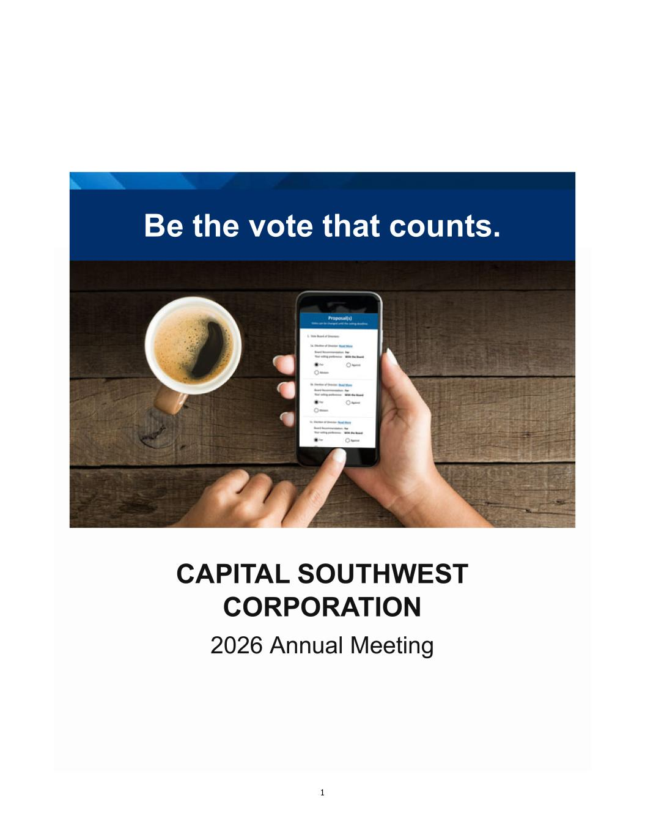
1 Be the vote that counts. CAPITAL SOUTHWEST CORPORATION 2026 Annual Meeting

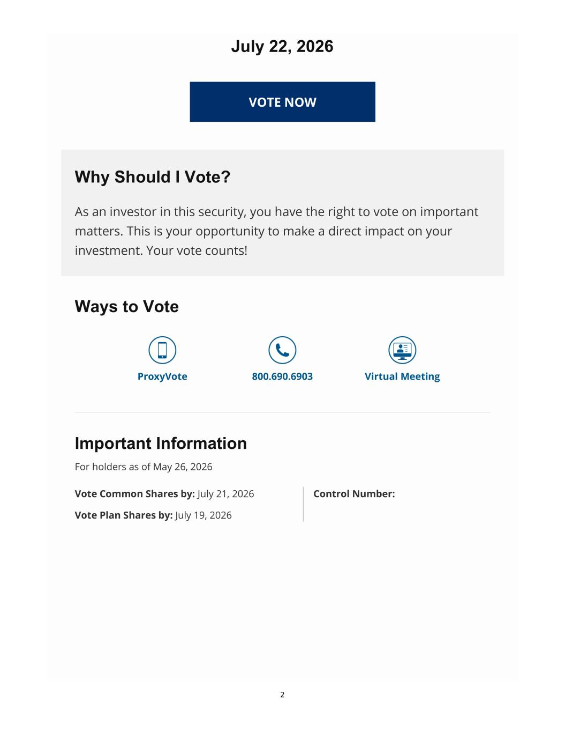
2 July 22, 2026 VOTE NOW Why Should I Vote? As an investor in this security, you have the right to vote on important matters. This is your opportunity to make a direct impact on your investment. Your vote counts! Ways to Vote ProxyVote 800.690.6903 Virtual Meeting Important Information For holders as of May 26, 2026 Vote Common Shares by: July 21, 2026 Control Number: Vote Plan Shares by: July 19, 2026

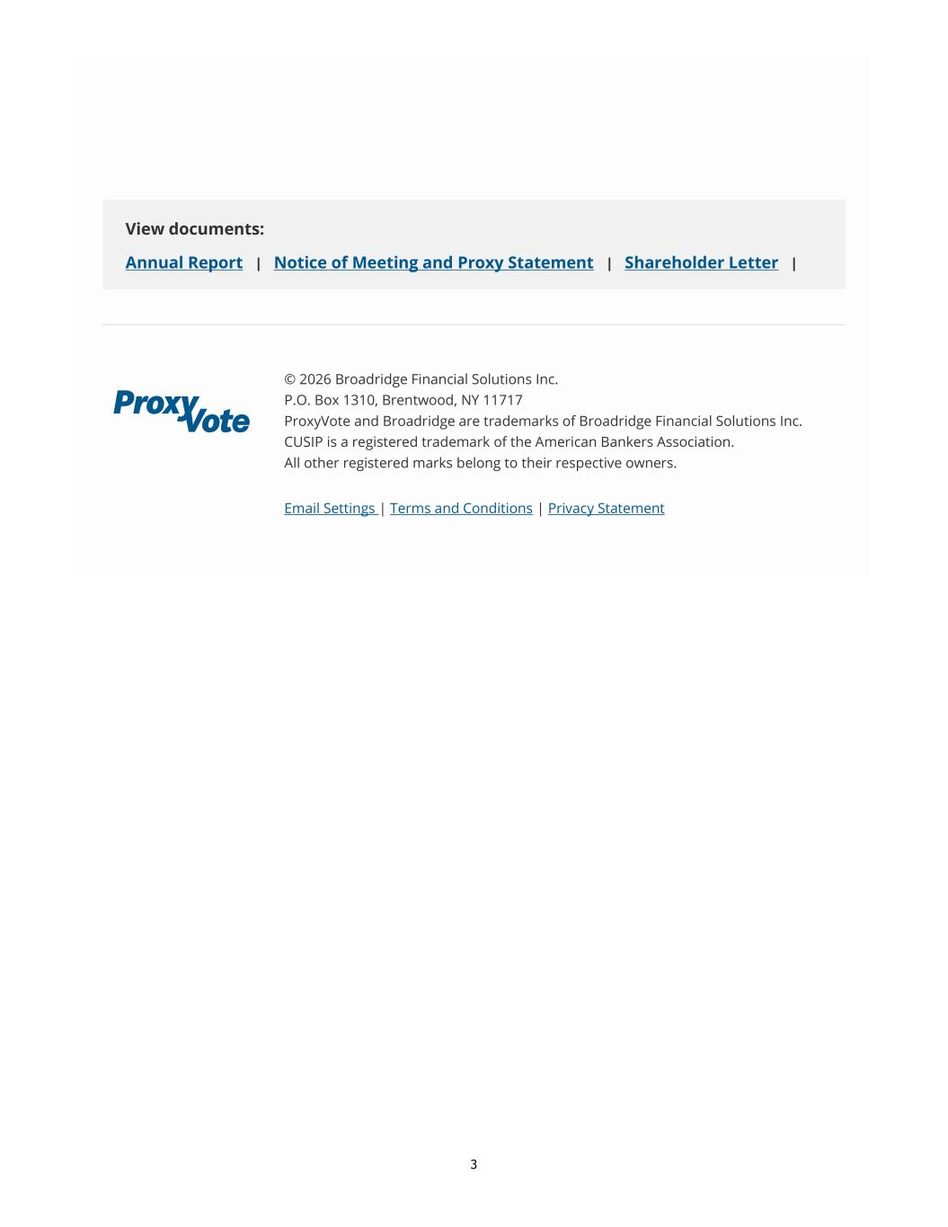
3 View documents: Annual Report | Notice of Meeting and Proxy Statement | Shareholder Letter | © 2026 Broadridge Financial Solutions Inc. P.O. Box 1310, Brentwood, NY 11717 ProxyVote and Broadridge are trademarks of Broadridge Financial Solutions Inc. CUSIP is a registered trademark of the American Bankers Association. All other registered marks belong to their respective owners. Email Settings | Terms and Conditions | Privacy Statement

